
Johor Port Berhad
Software Design Document (SDD)
Unsafe Conditions and Unsafe Acts System (UCUX)
Application unit, ICT Department, Johor Port Berhad
12-16-2025

Contents
1. Introduction 2
1.1 Purpose 2
1.3 Scope of Functionalities (Inclusions) 2
1.4 Scope Exclusions 3
2. System Architecture and Design 3
2.1 Methodology 3
2.2 System Architecture 3
3. Functional Requirements (Use Cases) 4
3.1 Key System Actors 4
3.2 Core Use Cases and Functions 5
3.3 Use Case Descriptions 6
4. Technical Specifications and Technology Stack 39
4.1 System Environment (WAMP Stack) 39
4.2 Development Tools 39
4.3 Frontend Technologies 39
4.4 Minimum Hardware Requirements 39
5. Data Design 39
5.1 Database Structure 40
5.2 Data Dictionary 40
6. Interface Design 51

Introduction
This software design document will describe the system architecture design, database design and user interface design for the Johor Port Unsafe Conditions Unsafe Acts System (UCUX). This document takes into account the requirements from the Software Requirement Specification.

1.1 Purpose
The following are the main purposes of this document:
- To describe the system architecture design and database design of the Johor Port Unsafe Conditions Unsafe Acts System (UCUX).
- To describe the user interface design of the Johor Port Unsafe Conditions Unsafe Acts System (UCUX).
1.2 System Objectives
The development objectives for the UCUX system include:
- To design and implement a comprehensive platform that provides centralized data storage for reporting and tracking unsafe conditions and actions.
- To facilitate the seamless capture, storage, and analysis of safety-related data, including reporting capabilities for data-driven decision-making.
- To develop and test the system to ensure it is effective, efficient, and user-friendly.
- To streamline safety management processes, reduce the risk of accidents and injuries, and improve overall operational efficiency in Johor Port Berhad (JPB).

1.3 Scope of Functionalities (Inclusions)
The UCUX system is designed to support the PSSD in managing and tracking complaints through the following key functionalities:
- User Management: Allows users to apply, check, verify, process, monitor, record, administrate, and manage complaint feedback.
- Complaint Tracking: Enables users to view the history and current status of each complaint.
- Evidence Management: Permits users to upload pictures and other evidence needed to support complaints.
- Reporting and Analysis: Generates reports and analyses based on complaint data, including complaint or offender information, feedback/comments, and the number of offenses.
- User Interface: Features a web-based interface providing a user-friendly experience.

1.4 Scope Exclusions
The UCUX system development explicitly excludes the following functionalities:
- Single Sign-On (SSO).
- Active Directory login/integration for user authentication and authorization.
- Advanced data analytics or machine learning capabilities (e.g., predictive algorithms, advanced visualization tools).
- Customized reporting or dashboards for specific users or roles.
- Advanced security features such as Multifactor Authentication (MFA) and compliance with specific security standards.
- Mobile or offline capabilities (e.g., offline access, data caching, native support for tablets).
- Advanced search or filtering capabilities (e.g., faceted search, drill-down capabilities).
- Webhooks for integration with external services or systems.

System Architecture and Design
This section describes the architectural style and rationale implemented in the Johor Port Unsafe Conditions Unsafe Acts System (UCUX). The architectural style used in Client-server architecture. This section will also further explain the user of Client-server as well as the breakdown of the Client-server architecture for this system.

2.1 Methodology
The chosen system development method is the Prototype Model. This methodology is preferred because the system requirements were initially not clearly understood or were subject to rapid change, allowing for the iterative refinement and testing of system components and interfaces.

2.2 System Architecture
The UCUX employs a Client-Server architecture based on a three-tier architecture structure. This design choice partitions application logic between the client (presentation) and the server (data processing and logic execution) to facilitate efficient management, operation, and maintenance.
The three main layers are:
- Presentation Tier: The application interface displayed to the user for interaction, such as data entry and display.
- Logic Tier (Server): Stores data, retrieves data from the data access layer, functions as a bridge, and coordinates data transfer between the presentation layer and the data access layer.
- Data Tier (Database): Builds queries and sends data parameters to the database server

3. Use Cases (Functional Requirements)
The system is defined by interactions between various actors and their associated use cases.
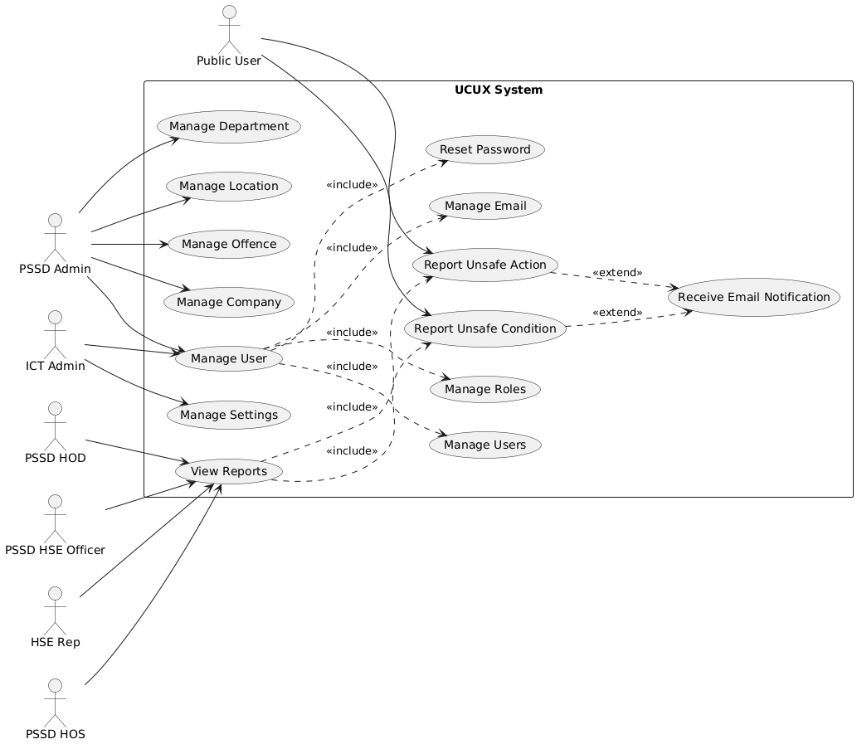
Figure 3.1. Use Case Diagram for UCUX

3.1 Key System Actors
The actors interacting with the system include:
- ICT Admin: Responsible for technical maintenance, unrestricted system access, creating and managing user roles, and configuring system settings.
- PSSD Admin: Manages administrative aspects, including user accounts, data management, and configuring email, company, department, and offense settings.
- Public User: Any individual (employee, contractor, visitor) using the system to report unsafe conditions and actions.
- PSSD HSE Officer: Responsible for investigating reported incidents, conducting risk assessments, implementing preventive measures, and reviewing reports.
- HSE Reps: Representatives responsible for validating a safe working environment and ensuring compliance.
- PSSD HOS (Head of Section): Responsible for ensuring port safety/security and reviewing/verifying hazardous condition reports.
- PSSD HOD (Head of Department): The senior official responsible for approving the unsafe conditions and actions reports.

3.2 Core Use Cases and Functions
Use Case | Actors | Function
User Management | ICT Admin, PSSD Admin | Create, update, and delete user accounts and profiles, including managing permissions.
User Roles | ICT Admin | Create and manage user roles, assigning permissions and access levels to maintain security and integrity.
Settings | ICT Admin | Configure and manage general system settings, company details, and system logs.
Manage Email | ICT Admin | Manage email settings for system configuration, including setting up email accounts and configuring email notifications/templates.
Manage Company, Department, Offense, Location | PSSD Admin | Manage information and settings related to external companies, internal departments, offense, location codes.
Unsafe Conditions | Public User | Report unsafe conditions, manage unsafe condition reports, and track report status.
Unsafe Actions | Public User | Report unsafe actions, manage unsafe action reports, and track report status.
Reports | Public User, PSSD HSE Officer, HSE Reps, PSSD HOS, PSSD HOD | Generate and manage various reports within the UCUX system, including tracking the status of reports.
Table 3.2.1. Core Use Cases and Functions table

3.3 Use Case Descriptions
Use Case: UC01: User Management
Primary Actor: ICT Admin
Goal: The ICT Admin wants to manage user accounts and profiles in the system to ensure secure and efficient access to the organization's resources.
Description:
The ICT Admin needs to create, update, and delete user accounts and profiles in the system. This includes adding new users, modifying existing user information, and removing inactive or terminated employees. The ICT Admin also needs to assign user roles and permissions to ensure that users have the necessary access to perform their job functions.
Triggers:
- New employee hire
- Employee termination
- Change in job role or responsibilities
- Request from a user to update their profile information
Preconditions:
- The ICT Admin has the necessary permissions and access to the system.
- The system is available and functioning correctly.
Basic Flow:
- The ICT Admin logs in to the system.
- The ICT Admin searches for the user account to be managed (create, update, or delete).
- The ICT Admin selects the desired action (create, update, or delete) and provides the necessary information (e.g., user name, password, role, permissions).
- The system validates the input and performs the requested action.
- The ICT Admin reviews the updated user account or profile information.
- The ICT Admin saves the changes or cancels the action.
Alternative Flows:
- If the ICT Admin tries to create a user account with an existing username, the system will prompt an error message and prevent the creation of the duplicate account.
- If the ICT Admin tries to delete a user account that is still active, the system will prompt a warning message and prevent the deletion.
Postconditions:
- The user account or profile information has been successfully created, updated, or deleted.
- The ICT Admin has been notified of any errors or warnings during the process.
Extensions:
- The ICT Admin can also reset user passwords or unlock locked accounts.
- The ICT Admin can view a list of all user accounts and their corresponding roles and permissions.
Table 3.3.1. Use case description for user management
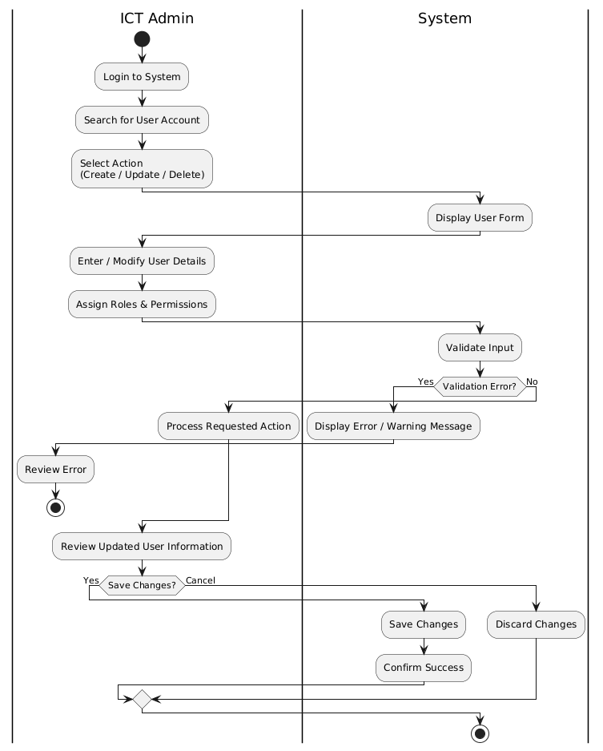
Figure 3.3.1. Activity diagram for user management
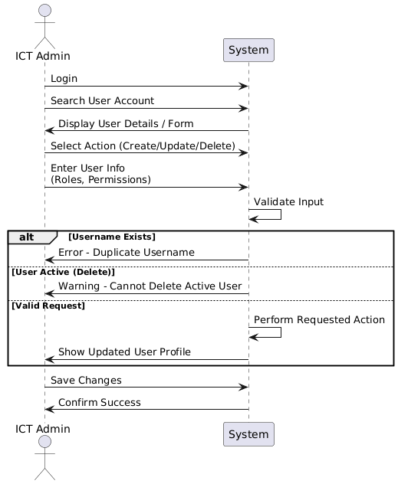
Figure 3.3.2. Sequence diagram for user management

Use Case: UC02: User Roles
Primary Actor: ICT Admin
Goal: To define and manage user roles within the Johor Port Berhad Unsafe Conditions and Unsafe Acts System (UCUX).
Description: The ICT Admin creates and manages user roles within the UCUX system, assigning permissions and access levels to each role. This ensures that users have the necessary access to perform their tasks and responsibilities, while also maintaining the security and integrity of the system.
Triggers:
- The ICT Admin needs to create a new user role
- A user's role needs to be updated or changed
- A user's access level needs to be adjusted
Preconditions:
- The ICT Admin has the necessary permissions and access to manage user roles
- The UCUX system is operational and accessible
Postconditions:
- The user role is created, updated, or changed as requested
- The user's access level is adjusted accordingly
- The UCUX system reflects the updated user role and access level
Main Flow:
- The ICT Admin logs into the UCUX system
- The ICT Admin navigates to the user role management page
- The ICT Admin creates a new user role or updates an existing one
- The ICT Admin assigns permissions and access levels to the user role
- The ICT Admin saves the changes
- The UCUX system reflects the updated user role and access level
Alternative Flows:
- If the ICT Admin encounters an error while creating or updating a user role, they may need to troubleshoot the issue or seek assistance from a higher authority.
- If a user's role needs to be deleted, the ICT Admin may need to ensure that the user's access level is adjusted accordingly and that the user is notified of the change.
Table 3.3.2. Use case description for user roles
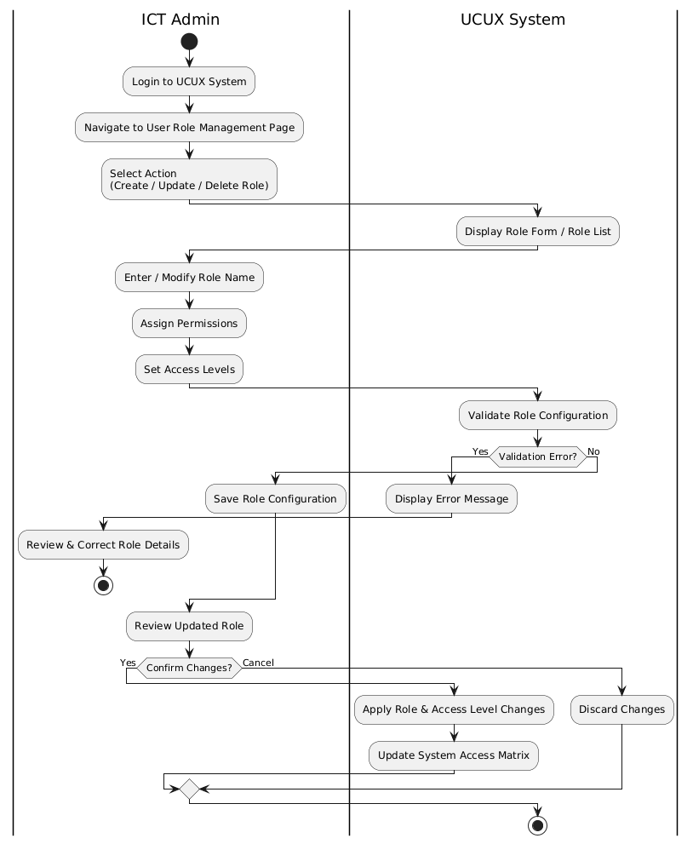
Figure 3.3.3 Activity diagram for user roles
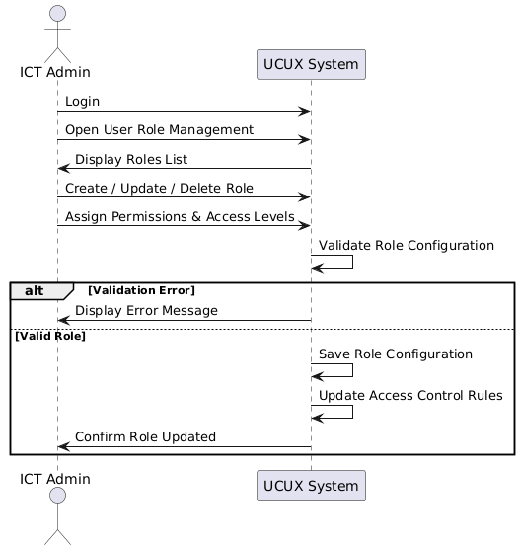
Figure 3.3.4 Sequence diagram for user roles

Use Case: UC03: Settings
Primary Actor: ICT Admin
Goal: To configure and manage system settings within the Johor Port Berhad Unsafe Conditions and Unsafe Acts System (UCUX).
Description: The ICT Admin configures and manages system settings within the UCUX system, ensuring that the system operates efficiently and effectively. This includes setting up system parameters, configuring notifications, and managing system logs.
Triggers:
- The ICT Admin needs to configure a new system setting
- A system setting needs to be updated or changed
- A system issue needs to be investigated and resolved
Preconditions:
- The ICT Admin has the necessary permissions and access to manage system settings
- The UCUX system is operational and accessible
Postconditions:
- The system setting is created, updated, or changed as requested
- The UCUX system reflects the updated system setting
- The system issue is investigated and resolved
Main Flow:
- The ICT Admin logs into the UCUX system
- The ICT Admin navigates to the system settings page
- The ICT Admin selects the system setting to be configured or updated
- The ICT Admin makes the necessary changes to the system setting
- The ICT Admin saves the changes
- The UCUX system reflects the updated system setting
Alternative Flows:
- If the ICT Admin encounters an error while configuring or updating a system setting, they may need to troubleshoot the issue or seek assistance from a higher authority.
- If a system issue needs to be investigated and resolved, the ICT Admin may need to review system logs, consult with other stakeholders, and implement a solution to resolve the issue.
Table 3.3.3. Use case description for settings
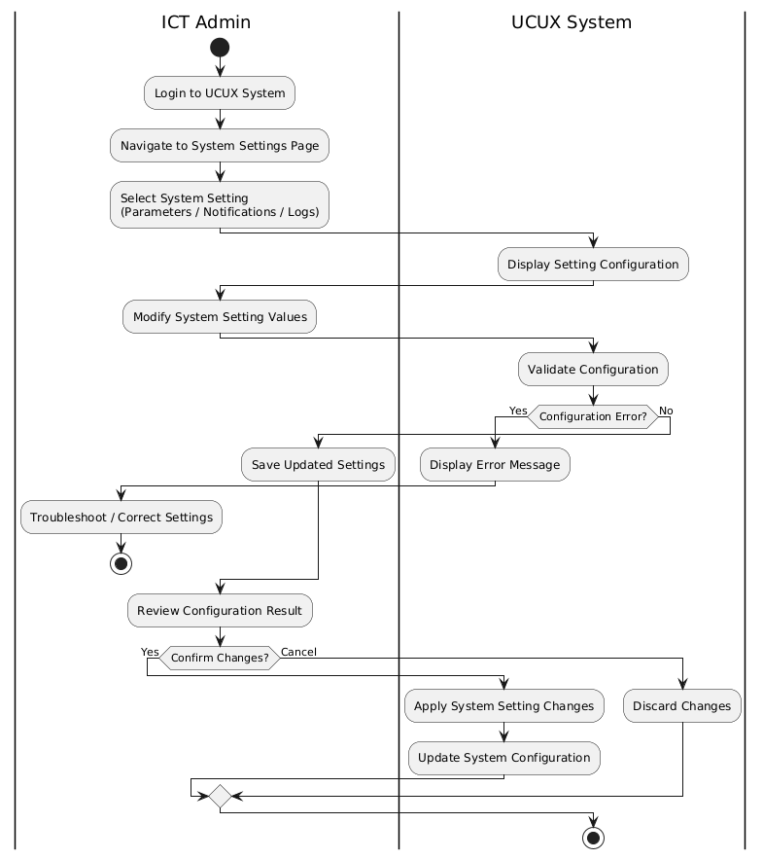
Figure 3.3.5 Activity diagram for settings
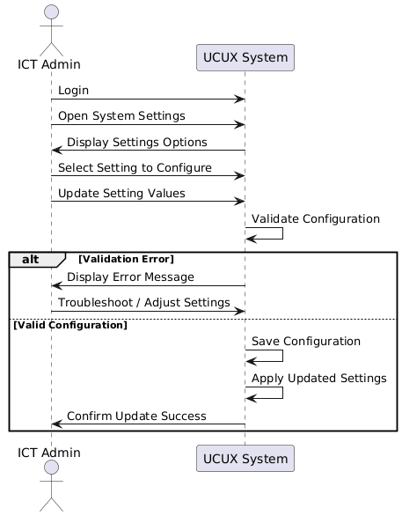
Figure 3.3.6 Sequence diagram for settings

Use Case: UC04: Manage Company
Primary Actor: PSSD Admin
Goal: To manage company information and settings within the Johor Port Berhad Unsafe Conditions and Unsafe Acts System (UCUX).
Description: The PSSD Admin manages company information and settings within the UCUX system, ensuring that the system is configured to meet the company's needs. This includes setting up company details, configuring company-wide settings, and managing company users.
Triggers:
- The PSSD Admin needs to update company information
- A company setting needs to be updated or changed
- A company user needs to be added or removed
Preconditions:
- The PSSD Admin has the necessary permissions and access to manage company settings
- The UCUX system is operational and accessible
Postconditions:
- The company information is updated as requested
- The company setting is updated or changed as requested
- The company user is added or removed as requested
Main Flow:
- The PSSD Admin logs into the UCUX system
- The PSSD Admin navigates to the company management page
- The PSSD Admin selects the company information or setting to be updated
- The PSSD Admin makes the necessary changes to the company information or setting
- The PSSD Admin saves the changes
- The UCUX system reflects the updated company information or setting
Alternative Flows:
- If the PSSD Admin encounters an error while updating company information or settings, they may need to troubleshoot the issue or seek assistance from a higher authority.
- If a company user needs to be added or removed, the PSSD Admin may need to ensure that the user's access level is adjusted accordingly and that the user is notified of the change.
Table 3.3.4. Use case description for manage company
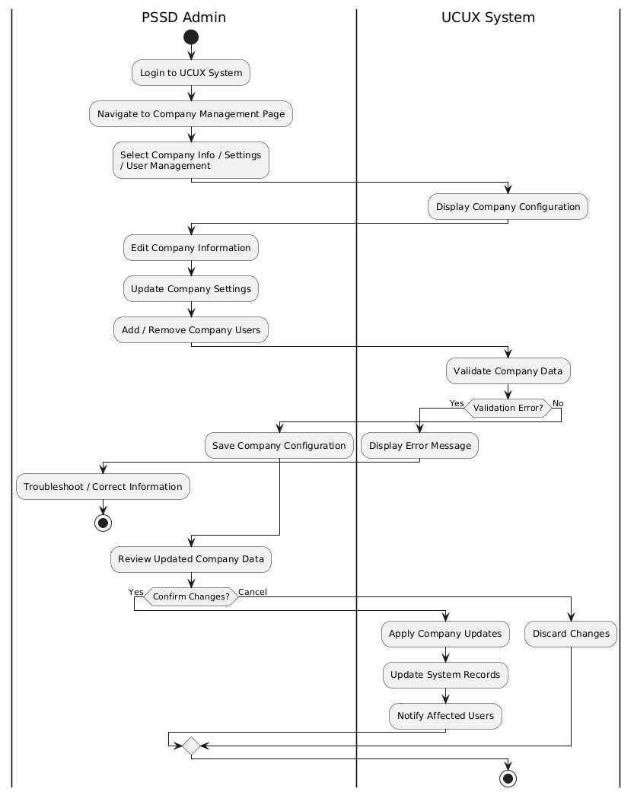
Figure 3.3.7. Activity diagram for manage company
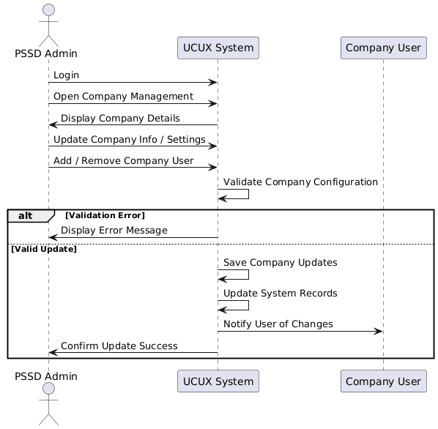
Figure 3.3.8. Sequence diagram for manage company

Use Case: UC05: Manage Department
Primary Actor: PSSD Admin
Goal: To manage department information and settings within the Johor Port Berhad Unsafe Conditions and Unsafe Acts System (UCUX).
Description: The PSSD Admin manages department information and settings within the UCUX system, ensuring that the system is configured to meet the department's needs. This includes setting up department details, configuring department-wide settings, and managing department users.
Triggers:
- The PSSD Admin needs to update department information
- A department setting needs to be updated or changed
- A department user needs to be added or removed
Preconditions:
- The PSSD Admin has the necessary permissions and access to manage department settings
- The UCUX system is operational and accessible
Postconditions:
- The department information is updated as requested
- The department setting is updated or changed as requested
- The department user is added or removed as requested
Main Flow:
- The PSSD Admin logs into the UCUX system
- The PSSD Admin navigates to the department management page
- The PSSD Admin selects the department information or setting to be updated
- The PSSD Admin makes the necessary changes to the department information or setting
- The PSSD Admin saves the changes
- The UCUX system reflects the updated department information or setting
Alternative Flows:
- If the PSSD Admin encounters an error while updating department information or settings, they may need to troubleshoot the issue or seek assistance from a higher authority.
- If a department user needs to be added or removed, the PSSD Admin may need to ensure that the user's access level is adjusted accordingly and that the user is notified of the change.
Table 3.3.5. Use case description for manage department
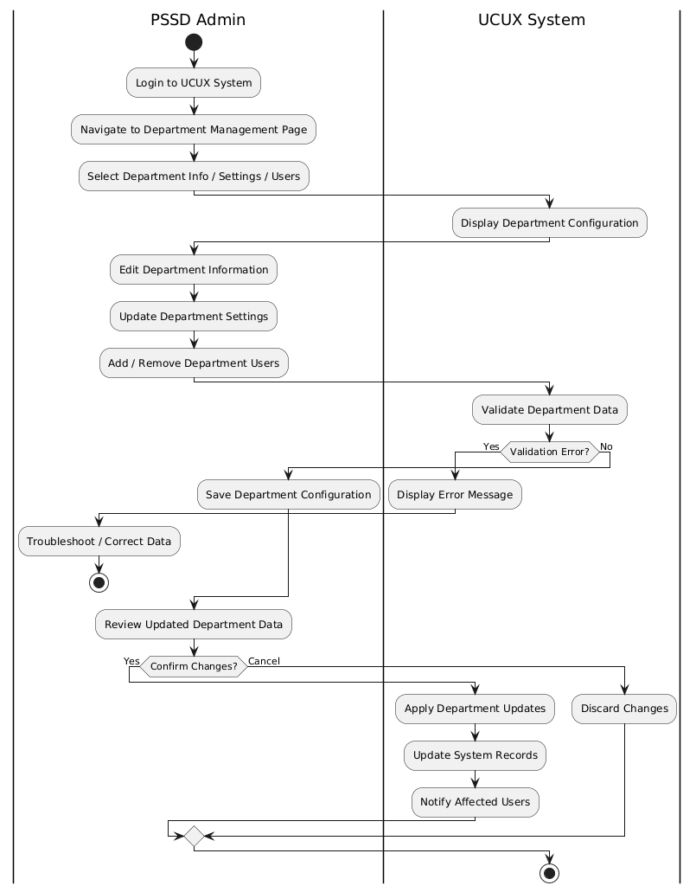
Figure 3.3.9. Activity diagram for manage department
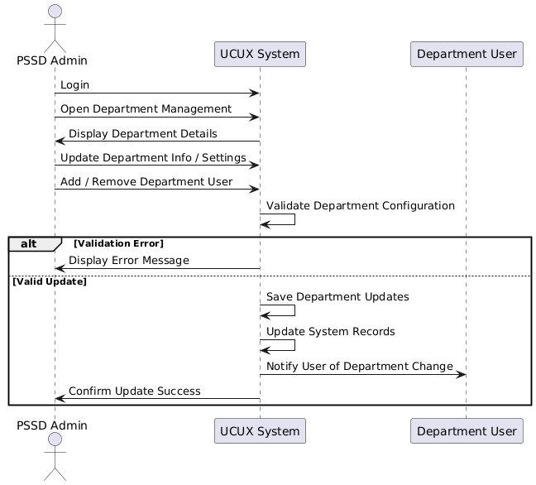
Figure 3.3.10. Sequence diagram for manage department

Use Case: UC06: Manage Offense
Primary Actor: PSSD Admin
Goal: To manage offense information and settings within the Johor Port Berhad Unsafe Conditions and Unsafe Acts System (UCUX).
Description: The PSSD Admin manages offense information and settings within the UCUX system, ensuring that the system is configured to meet the offense's needs. This includes setting up offense details, configuring offense-wide settings, and managing offense users.
Triggers:
- The PSSD Admin needs to update offense information
- An offense setting needs to be updated or changed
- An offense user needs to be added or removed
Preconditions:
- The PSSD Admin has the necessary permissions and access to manage offense settings
- The UCUX system is operational and accessible
Postconditions:
- The offense information is updated as requested
- The offense setting is updated or changed as requested
- The offense user is added or removed as requested
Main Flow:
- The PSSD Admin logs into the UCUX system
- The PSSD Admin navigates to the offense management page
- The PSSD Admin selects the offense information or setting to be updated
- The PSSD Admin makes the necessary changes to the offense information or setting
- The PSSD Admin saves the changes
- The UCUX system reflects the updated offense information or setting
Alternative Flows:
- If the PSSD Admin encounters an error while updating offense information or settings, they may need to troubleshoot the issue or seek assistance from a higher authority.
- If an offense user needs to be added or removed, the PSSD Admin may need to ensure that the user's access level is adjusted accordingly and that the user is notified of the change.
Table 3.3.6. Use case description for manage offences
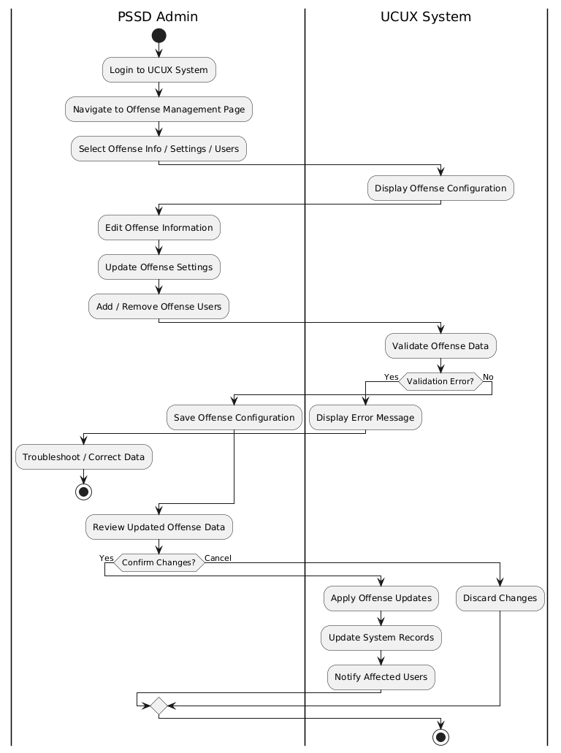
Figure 3.3.11. Activity diagram for manage offense
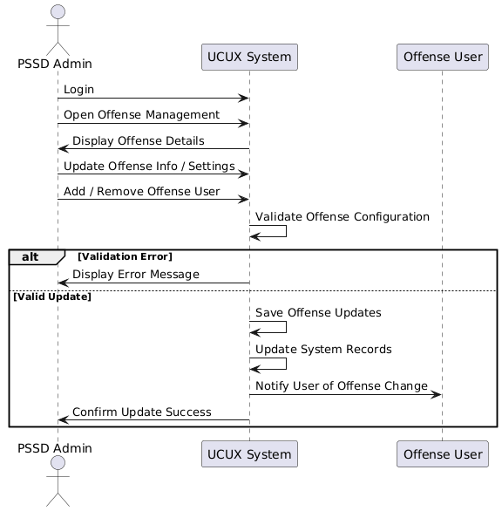
Figure 3.3.12. Sequence diagram for manage offense

Use Case: UC07 – Manage Location
Primary Actor: PSSD Admin
Goal: To manage location information within the Johor Port Berhad Unsafe Conditions and Unsafe Acts System (UCUX) to ensure accurate identification, reporting, and tracking of unsafe conditions and unsafe actions.
Description: The PSSD Admin manages location information within the UCUX system. This includes creating, updating, and maintaining location records used during unsafe condition and unsafe action reporting. Proper location management ensures that reports are accurately linked to physical areas within Johor Port Berhad and supports effective monitoring, investigation, and corrective actions.
Triggers:
- A new operational area or facility is added
- An existing location needs to be updated or renamed
- A location is no longer in use and needs to be deactivated
- Incorrect or missing location information is identified in reports
Preconditions:
- The PSSD Admin has valid credentials and authorization to manage locations
- The UCUX system is operational and accessible
Postconditions:
- The location information is successfully created, updated, or deactivated
- The updated location list is reflected in unsafe condition and unsafe action reporting forms
- Existing reports remain linked to valid location records
Main Flow:
  - The PSSD Admin logs into the UCUX system
  - The PSSD Admin navigates to the Location Management page
  - The PSSD Admin views the list of existing locations
  - The PSSD Admin selects an action:
- Create new location
- Update existing location
- Deactivate location
  - The PSSD Admin enters or modifies location details, such as:
- Location name
- Area/zone
- Description
- Status (Active/Inactive)
  - The PSSD Admin saves the changes
  - The UCUX system validates and stores the location information
  - The UCUX system updates the location list used in unsafe condition and unsafe action reporting
Alternative Flows:
  - Duplicate Location
- If the PSSD Admin attempts to create a location with an existing name, the system displays an error message and prevents duplication.
  - Location in Use
- If the PSSD Admin attempts to deactivate a location that is currently referenced by active reports, the system prevents deactivation and prompts the admin to resolve or reassign the reports.
  - System Error
- If an error occurs while saving location information, the system displays an error message and allows the PSSD Admin to retry or cancel the action.
Table 3.3.7. Use case description for manage location

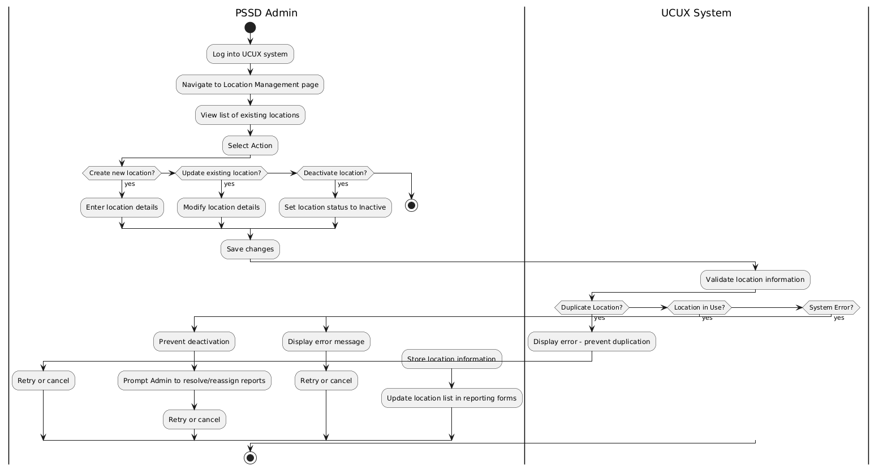
Figure 3.3.13. Activity diagram for manage location
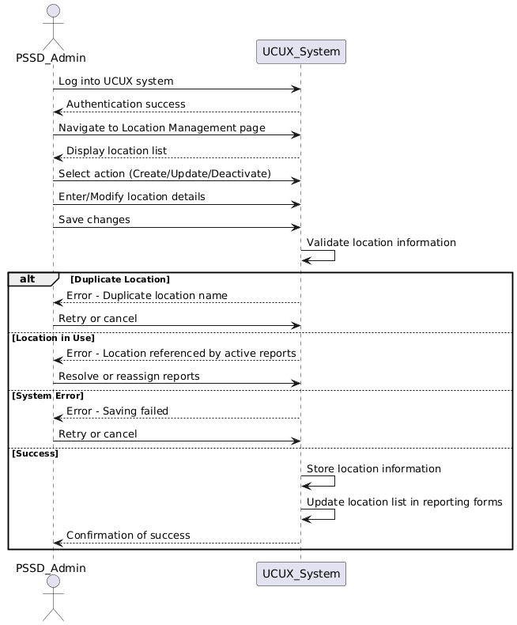
Figure 3.3.14. Sequence diagram for manage location

Use Case: UC08: Manage Email
Primary Actor: PSSD Admin
Goal: To manage email settings and configurations within the Johor Port Berhad Unsafe Conditions and Unsafe Acts System (UCUX).
Description: The PSSD Admin manages email settings and configurations within the UCUX system, ensuring that the system is configured to meet the email needs of the organization. This includes setting up email accounts, configuring email notifications, and managing email templates.
Triggers:
- The PSSD Admin needs to update email settings
- An email notification needs to be updated or changed
- An email template needs to be created or updated
Preconditions:
- The PSSD Admin has the necessary permissions and access to manage email settings
- The UCUX system is operational and accessible
Postconditions:
- The email settings are updated as requested
- The email notification is updated or changed as requested
- The email template is created or updated as requested
Main Flow:
- The PSSD Admin logs into the UCUX system
- The PSSD Admin navigates to the email management page
- The PSSD Admin selects the email setting or notification to be updated
- The PSSD Admin makes the necessary changes to the email setting or notification
- The PSSD Admin saves the changes
- The UCUX system reflects the updated email setting or notification
Alternative Flows:
- If the PSSD Admin encounters an error while updating email settings or notifications, they may need to troubleshoot the issue or seek assistance from a higher authority.
- If an email template needs to be created or updated, the PSSD Admin may need to ensure that the template is properly formatted and that the email notification is properly configured.
Table 3.3.8. Use case description for manage email
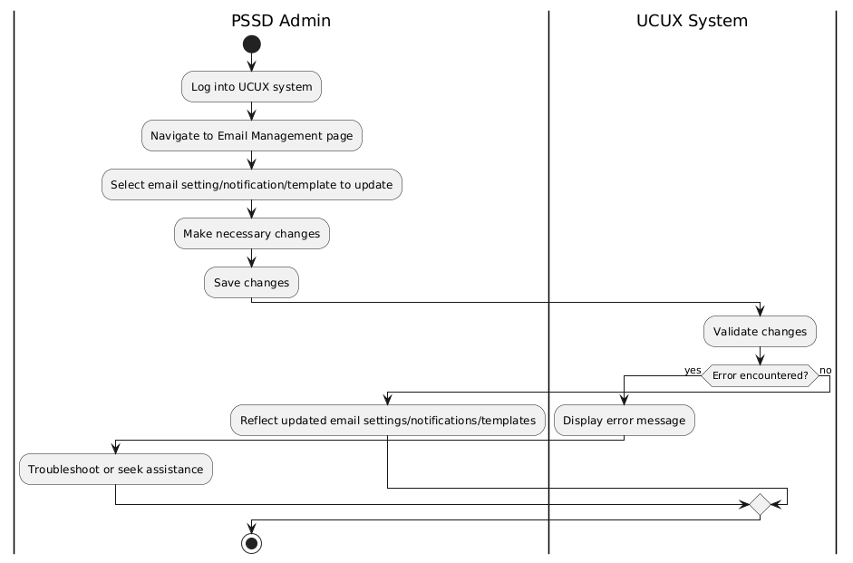
Figure 3.3.15. Activity diagram for manage email
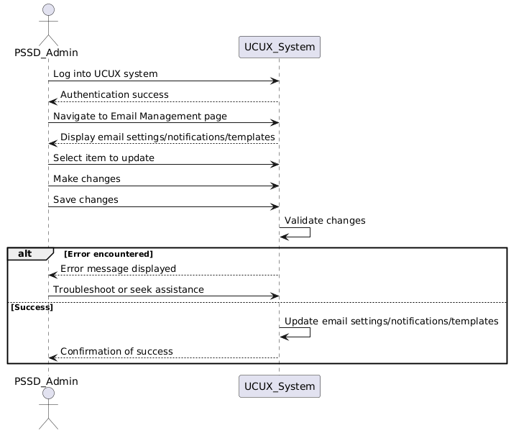
Figure 3.3.16. Sequence diagram for manage email

Use Case: UC09: Unsafe Conditions
Primary Actor: Public User
Goal: To report and manage unsafe conditions within the Johor Port Berhad Unsafe Conditions and Unsafe Acts System (UCUX).
Description: The Public User reports and manages unsafe conditions within the UCUX system, ensuring that the system is configured to meet the needs of the organization. This includes reporting unsafe conditions, managing unsafe condition reports, and tracking the status of unsafe condition reports.
Triggers:
- The Public User needs to report an unsafe condition
- An unsafe condition report needs to be updated or changed
- An unsafe condition report needs to be closed or resolved
Preconditions:
- The Public User has the necessary permissions and access to report unsafe conditions
- The UCUX system is operational and accessible
Postconditions:
- The unsafe condition report is created as requested
- The unsafe condition report is updated or changed as requested
- The unsafe condition report is closed or resolved as requested
Main Flow:
- The Public User logs into the UCUX system
- The Public User navigates to the unsafe condition reporting page
- The Public User selects the unsafe condition to be reported
- The Public User provides the necessary information for the unsafe condition report
- The Public User submits the unsafe condition report
- The UCUX system send notification to PSSD HSE Officer Verify/Filter, Reject or Approve the created unsafe condition report
- PSSD HSE Officer notify related department and notify HSE Reps
- HSE Reps to upload photos after action taken
- PSSD HSE Officer confirm action taken and notify related PSSD HOS
- PSSD HOS to approve/confirm the created unsafe condition report and notify PSSD HOD
- PSSD HOD to confirm and full close the unsafe condition report
Alternative Flows:
- If the Public User encounters an error while reporting an unsafe condition, they may need to troubleshoot the issue or seek assistance from a higher authority.
- If an unsafe condition report needs to be updated or changed, the Public User may need to ensure that the report is properly updated and that the necessary changes are made.
Table 3.3.10. Use case description for unsafe condition
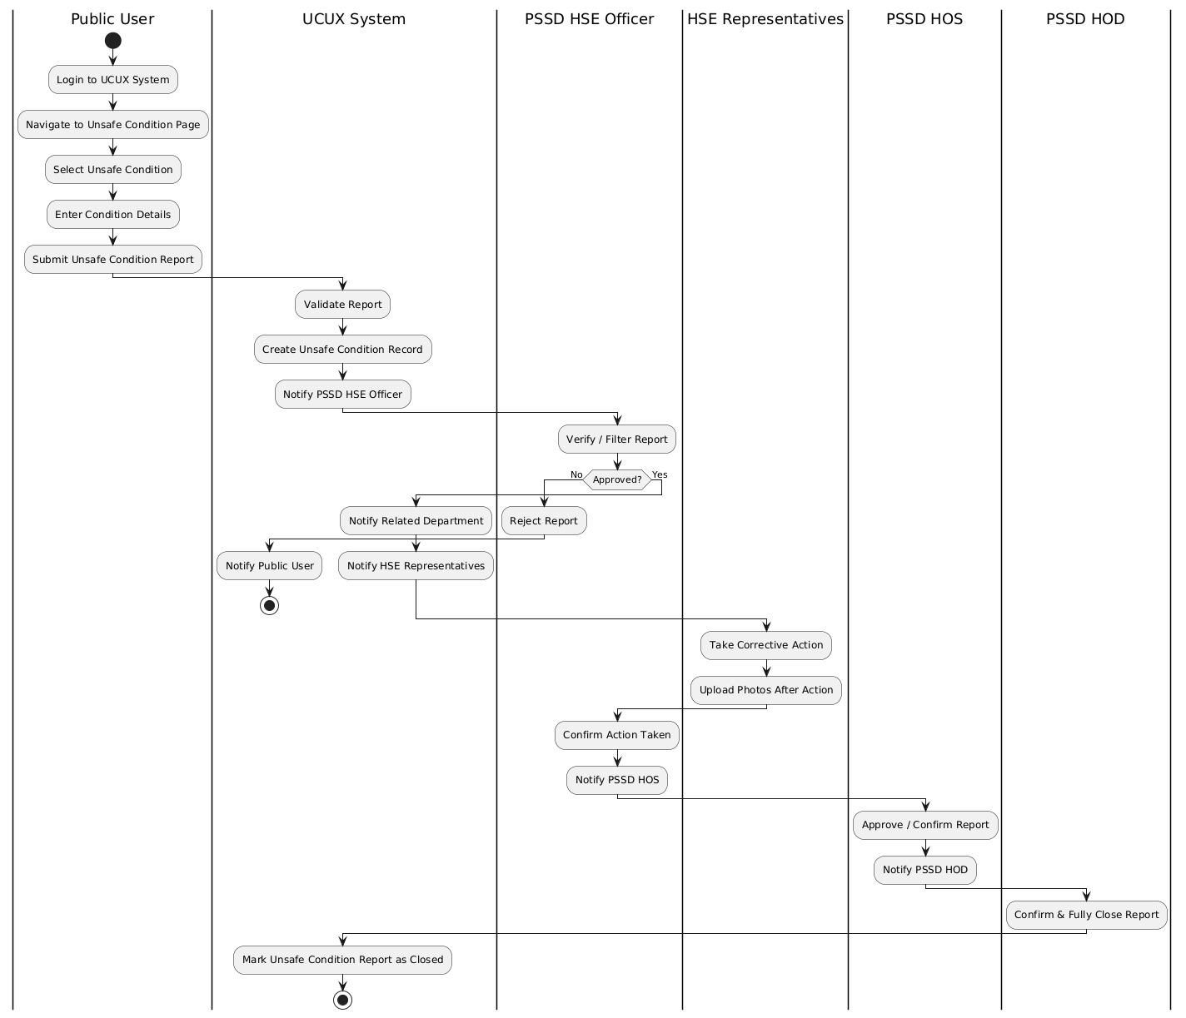
Figure 3.3.17. Activity diagram for unsafe conditions
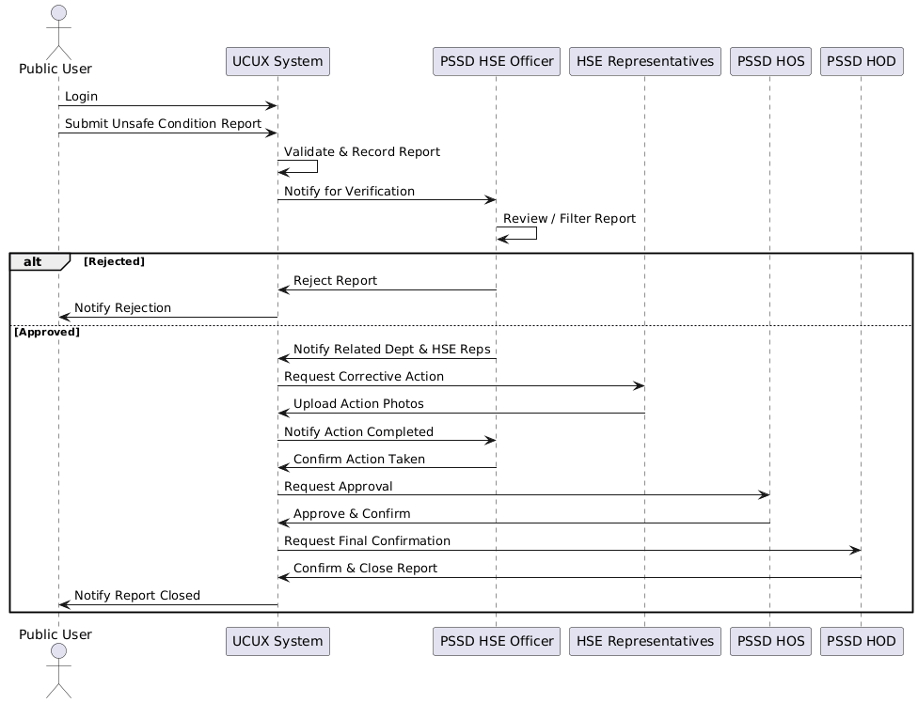
Figure 3.3.18. Sequence diagram for unsafe conditions

Use Case: UC10: Unsafe Actions
Primary Actor: Public User
Goal: To report and manage unsafe actions within the Johor Port Berhad Unsafe Conditions and Unsafe Acts System (UCUX).
Description: The Public User reports and manages unsafe actions within the UCUX system, ensuring that the system is configured to meet the needs of the organization. This includes reporting unsafe actions, managing unsafe action reports, and tracking the status of unsafe action reports.
Triggers:
- The Public User needs to report an unsafe action
- An unsafe action report needs to be updated or changed
- An unsafe action report needs to be closed or resolved
Preconditions:
- The Public User has the necessary permissions and access to report unsafe actions
- The UCUX system is operational and accessible
Postconditions:
- The unsafe action report is created as requested
- The unsafe action report is updated or changed as requested
- The unsafe action report is closed or resolved as requested
Main Flow:
- The Public User logs into the UCUX system
- The Public User navigates to the unsafe action reporting page
- The Public User selects the unsafe action to be reported
- The Public User provides the necessary information for the unsafe action report
- The Public User submits the unsafe action report
- The UCUX system reflects the created unsafe action report
Alternative Flows:
- If the Public User encounters an error while reporting an unsafe action, they may need to troubleshoot the issue or seek assistance from a higher authority.
- If an unsafe action report needs to be updated or changed, the Public User may need to ensure that the report is properly updated and that the necessary changes are made.
Table 3.3.11. Use case description for unsafe action
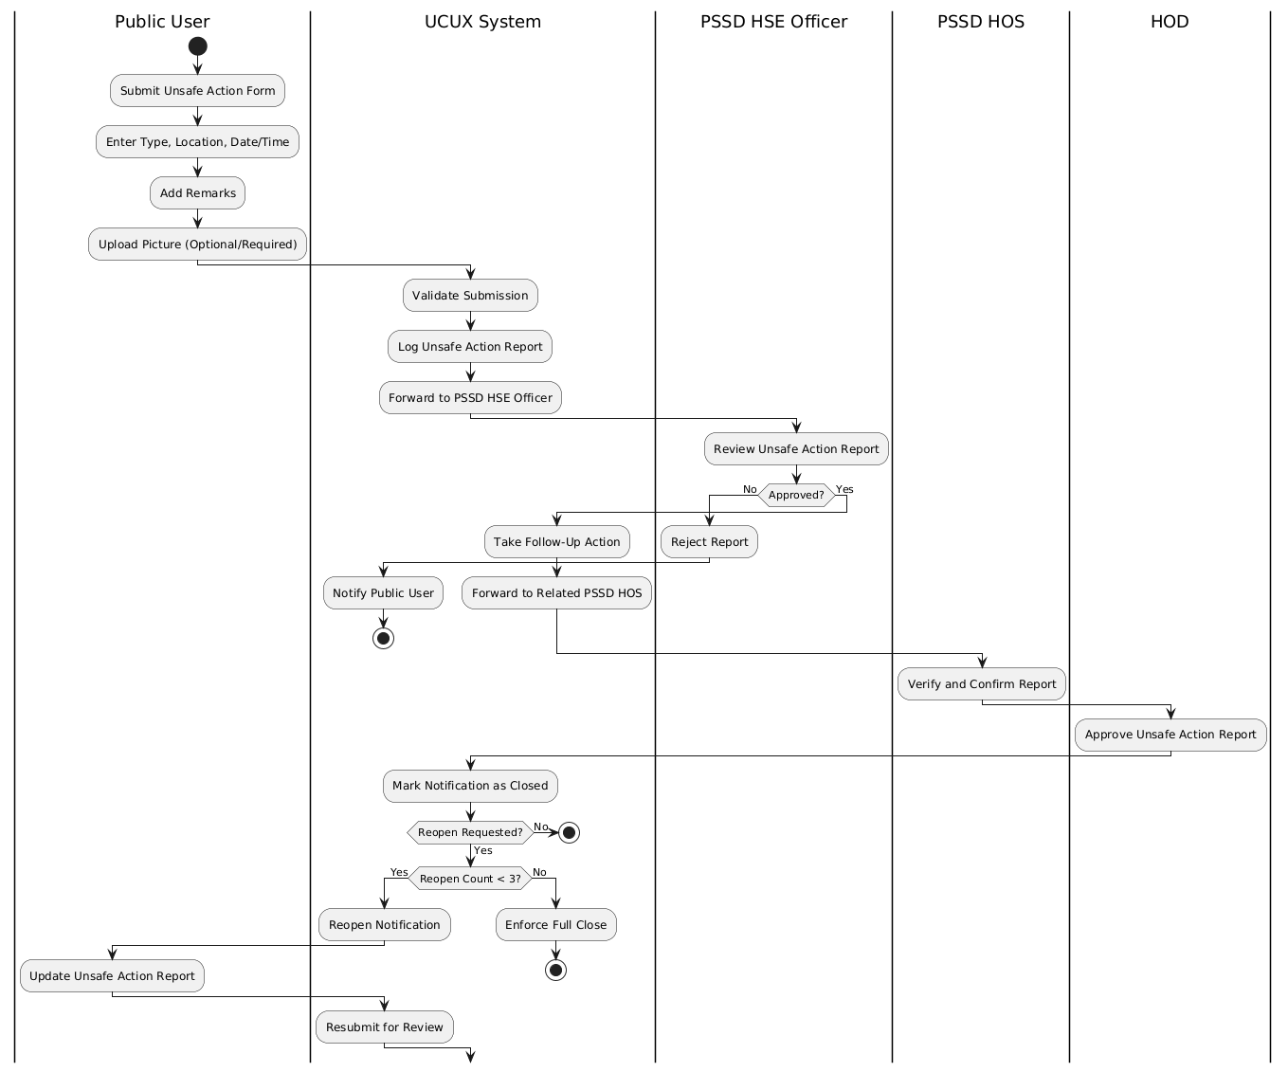
Figure 3.3.19. Activity diagram for Unsafe Actions
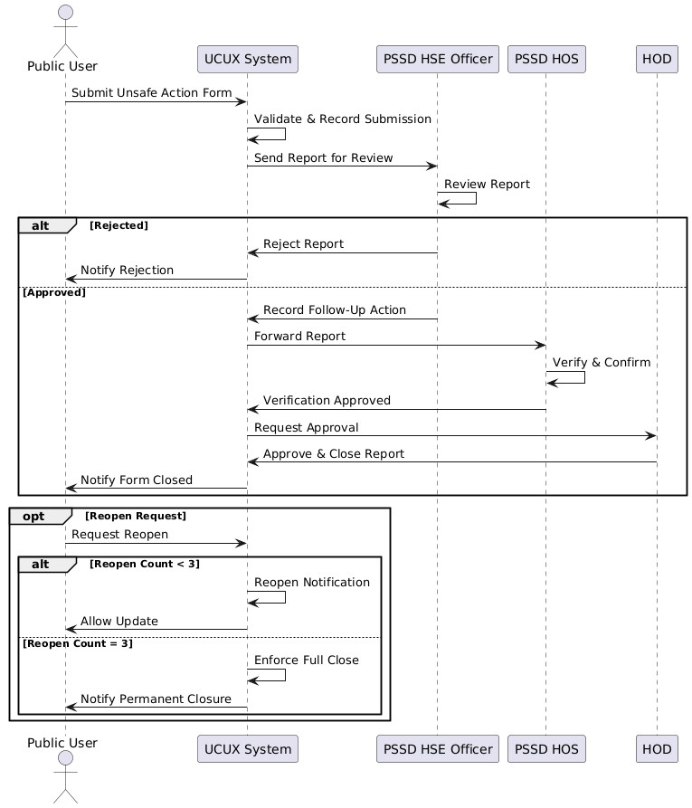
Figure 3.3.20. Sequence diagram for unsafe actions

Use Case: UC11: Reports
Primary Actors: ICT Admin, PSSD Admin, Public User, PSSD HSE Officer, HSE Reps, PSSD HOS, PSSD HOD
Goal: To generate and manage reports within the Johor Port Berhad Unsafe Conditions and Unsafe Acts System (UCUX).
Description: The primary actors generate and manage reports within the UCUX system, ensuring that the system is configured to meet the needs of the organization. This includes generating reports, managing report templates, and tracking the status of reports.
Triggers:
- The ICT Admin needs to generate a report
- The PSSD Admin needs to generate a report
- The Public User needs to generate a report
- The PSSD HSE Officer needs to generate a report
- The HSE Reps need to generate a report
- The PSSD HOS needs to generate a report
- The PSSD HOD needs to generate a report
Preconditions:
- The primary actors have the necessary permissions and access to generate reports
- The UCUX system is operational and accessible
Postconditions:
- The report is generated as requested
- The report is updated or changed as requested
- The report is closed or resolved as requested
Main Flow:
- The primary actor logs into the UCUX system
- The primary actor navigates to the report generation page
- The primary actor selects the report template or generates a new report
- The primary actor provides the necessary information for the report
- The primary actor submits the report
- The UCUX system reflects the generated report
Alternative Flows:
- If the primary actor encounters an error while generating a report, they may need to troubleshoot the issue or seek assistance from a higher authority.
- If a report needs to be updated or changed, the primary actor may need to ensure that the report is properly updated and that the necessary changes are made.
- If a report needs to be closed or resolved, the primary actor may need to ensure that the report is properly closed or resolved and that the necessary actions are taken.
Table 3.3.12. Use case description for reports
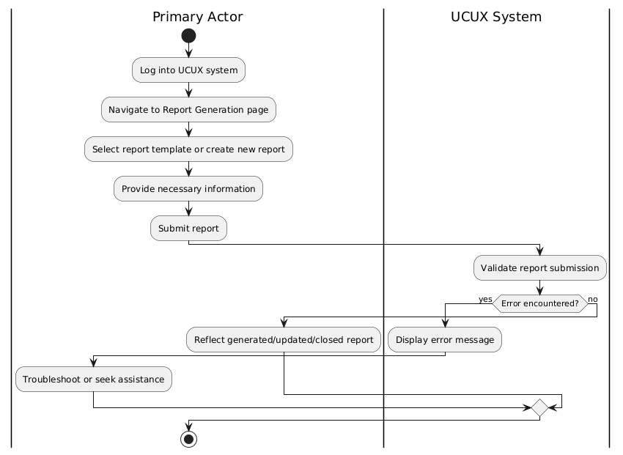
Figure 3.3.21. Activity diagram for reports
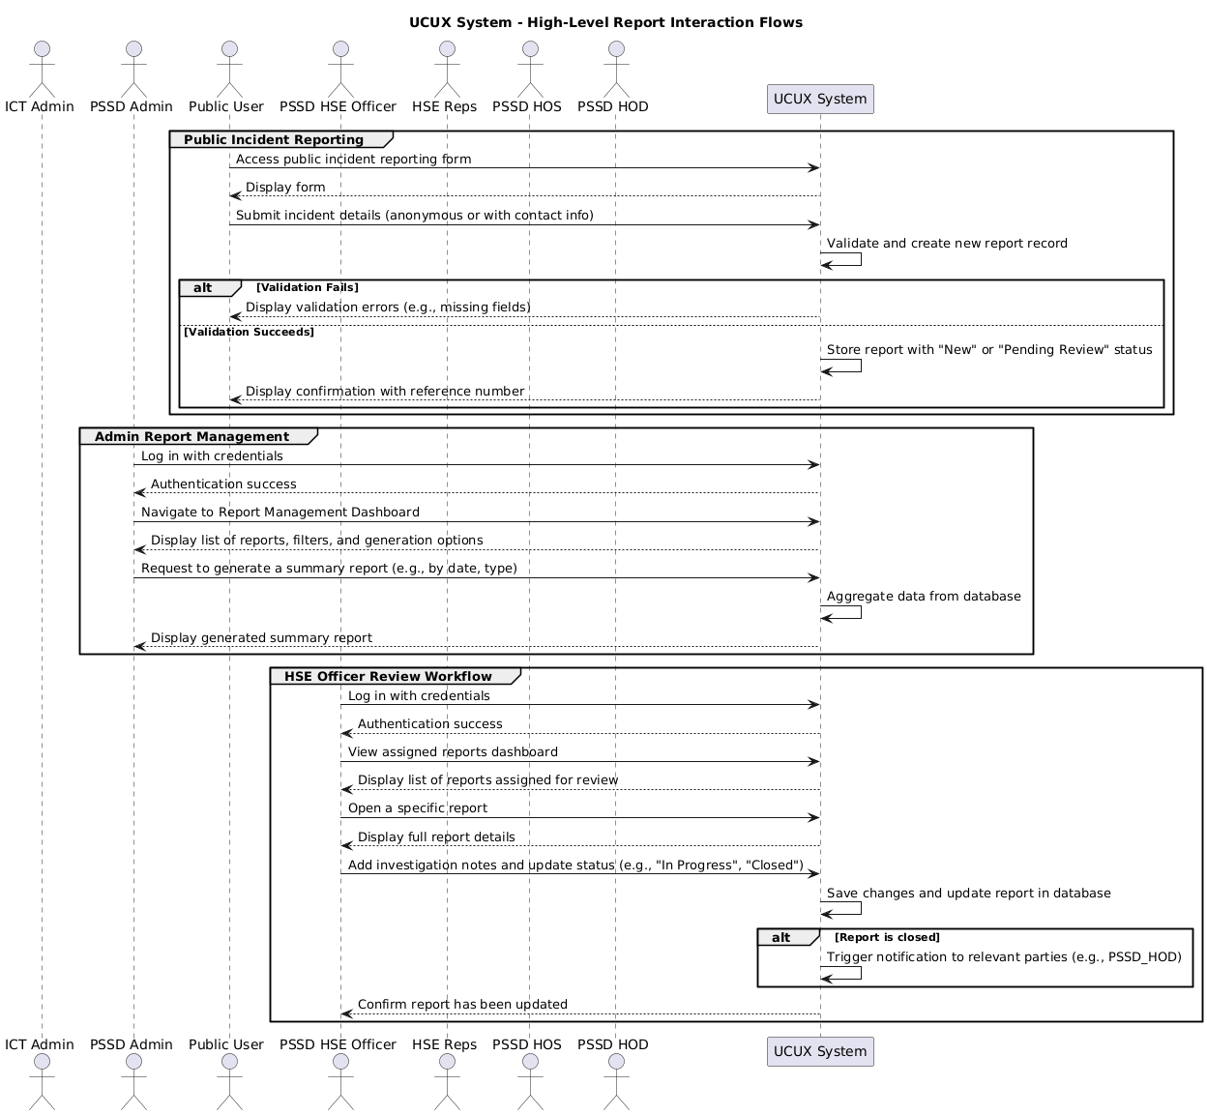
Figure 3.3.22. Sequence diagram for reports

4. Technical Specifications and Technology Stack
The design of the UCUX system utilizes the following hardware and software technologies:

4.1 System Environment (WAMP Stack)
The system development utilized the WAMP stack, providing a localized development server environment for rigorous testing.
- Operating System (OS): Windows 10 Pro version 22H2.
- Web Server: Apache HTTP 2.4.57.
- Database: MySQL 8.
- Scripting Language: PHP 8.3.0.
- Environment: Laragon 6.0.
- Database Administration: PhpMyAdmin 5.2.1.
- Email Library: PHPMailer (used for email-sending functionalities).

4.2 Development Tools
- Integrated Development Environment (IDE): VSCodium 1.96.0.
- Version Control: GitHub.
- Modelling Language: Unified Modelling Language (UML).
- Prototyping/Wireframing Tool: Figma (used for high-fidelity mock-ups).

4.3 Frontend Technologies
The frontend is designed to be mobile-first and responsive.
- CSS Framework: Bootstrap (robust open-source toolkit for responsive design).
- JavaScript Library: jQuery (used for navigating the HTML DOM, handling events, and making Ajax requests).
- Data Visualization: CanvasJS (HTML5 and JavaScript charting library for interactive charts/graphs, used in dashboard modules).

4.4 Minimum Hardware Requirements
The minimum hardware specifications for optimal system performance are:
- CPU: Intel Core i7.
- RAM: 16.0 GB.
- Storage: 1 TB SDD.
- Network: 1000 MB and above access.

Data Design
This section describes the database structure and the relationships between tables. Data is stored, processed, and managed in a database.

5.1 Database Structure
The database functions as a centralized repository for organized data, aiming to minimize duplication and ensure efficient, secure management. The logical database structure is visualized through an Entity Relationship Diagram.

5.2 Data Dictionary
The data dictionary describes the data structure design for each table involved in the database. The data structure involves fields, data types, and their descriptions.
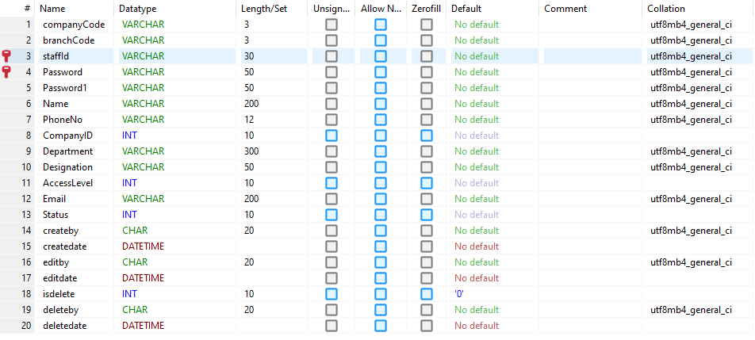
Figure 5.2.1. User table
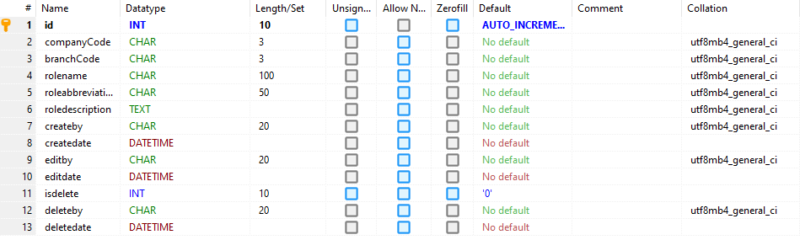
Figure 5.2.2. User Roles table
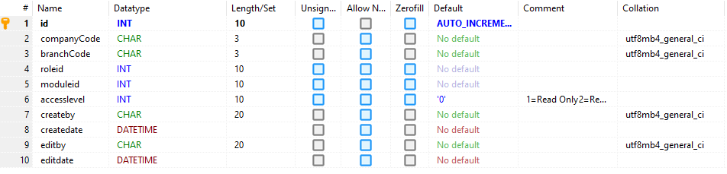
Figure 5.2.3. User Rights table
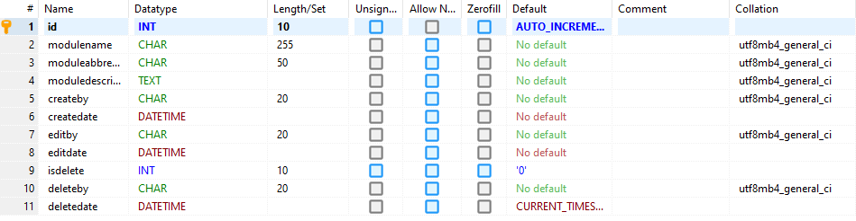
Figure 5.2.4. User Modules table
Figure 5.2.5. User Form table
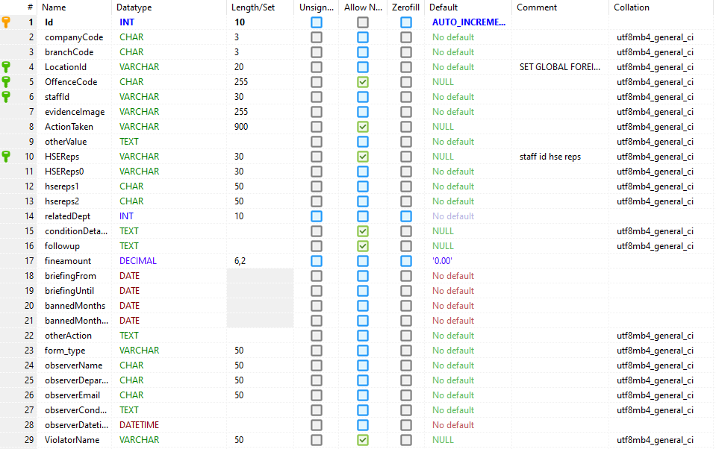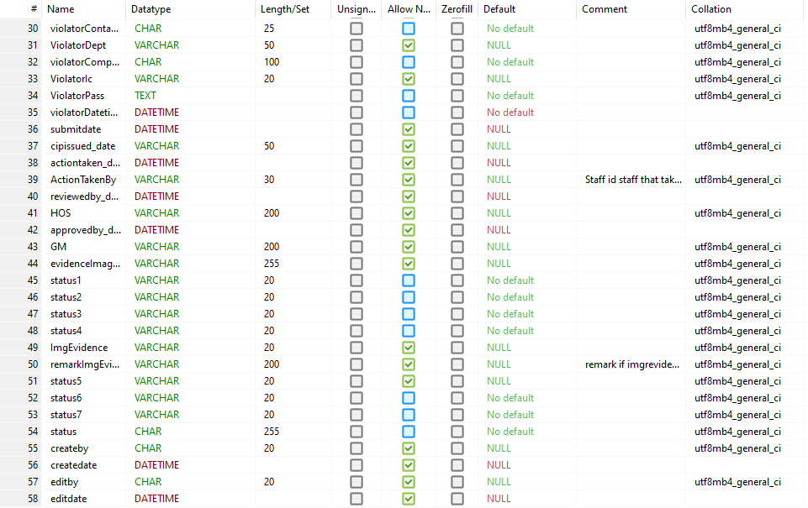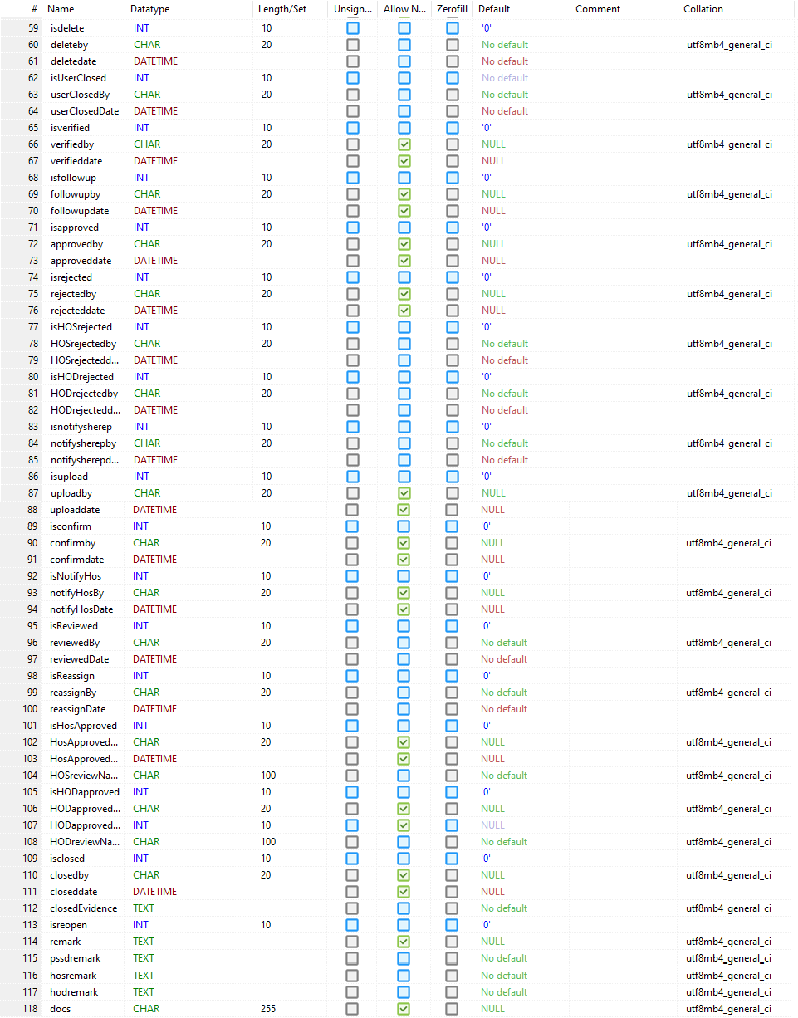
Figure 5.2.6. Ucuaform table
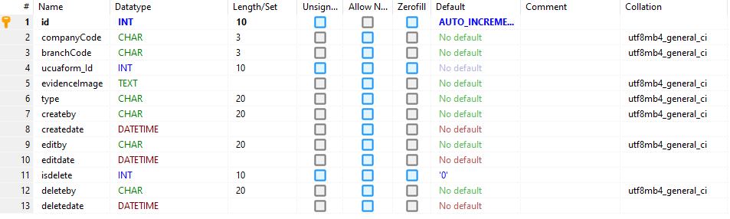
Figure 5.2.7. Ucuaphoto table
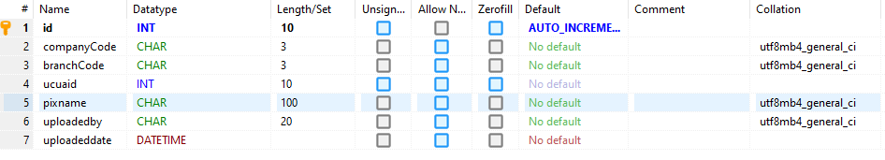
Figure 5.2.8. Ucuapix table
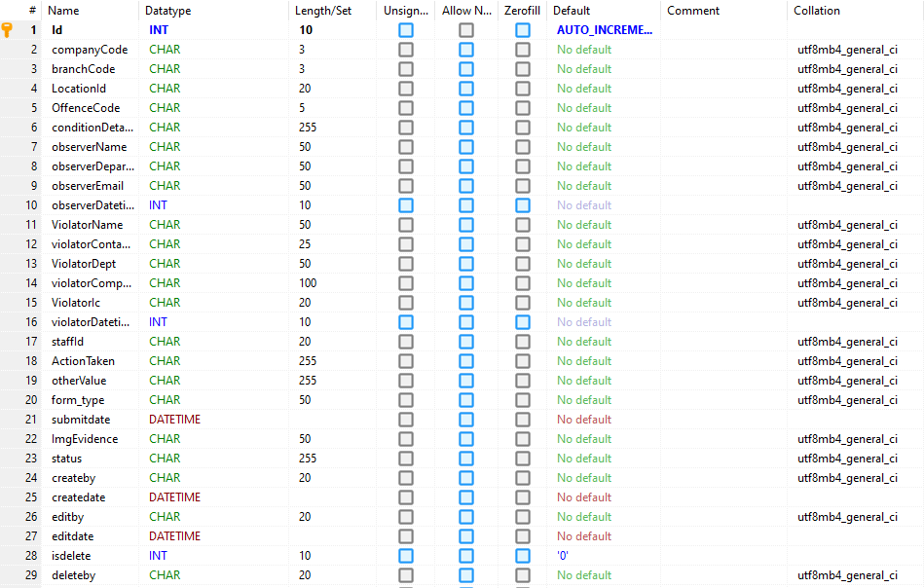
Figure 5.2.9. Ucuadraft table
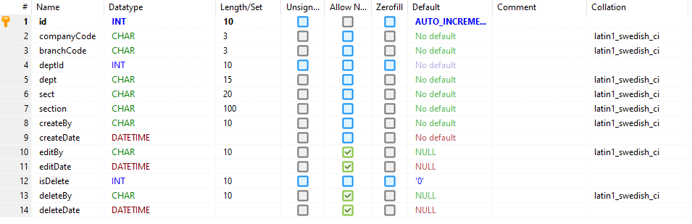
Figure 5.2.10. Prefix table
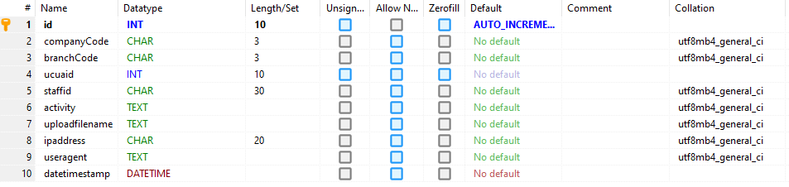
Figure 5.2.11. Activity table
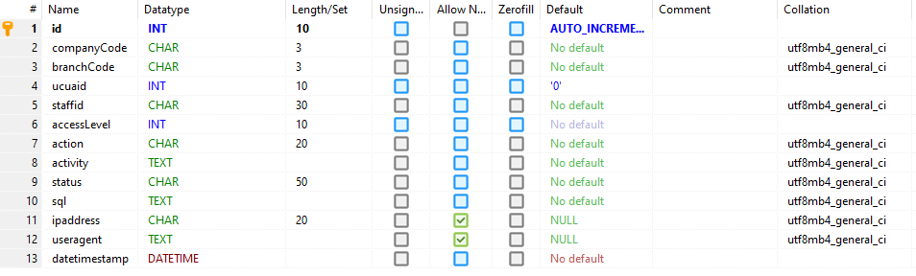
Figure 5.2.12. History table
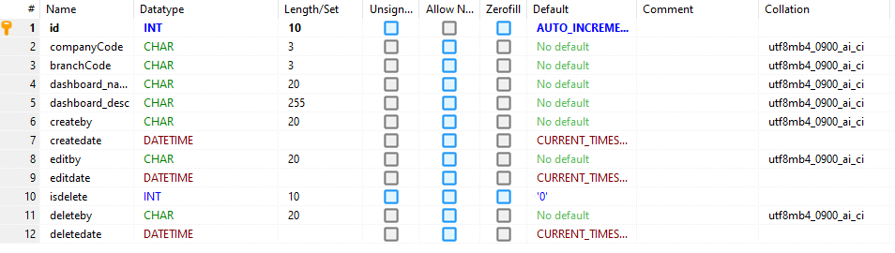
Figure 5.2.13. Dashboard table
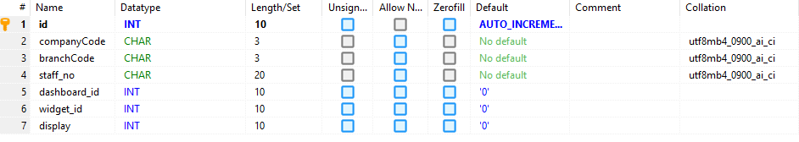
Figure 5.2.14. Dashboard Settings table
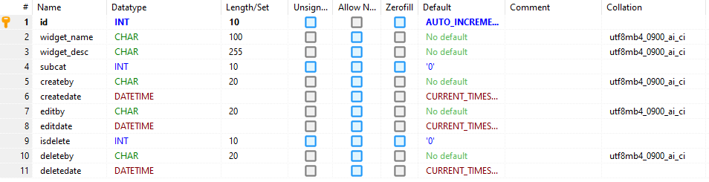
Figure 5.2.15. Dashboard Widgets table
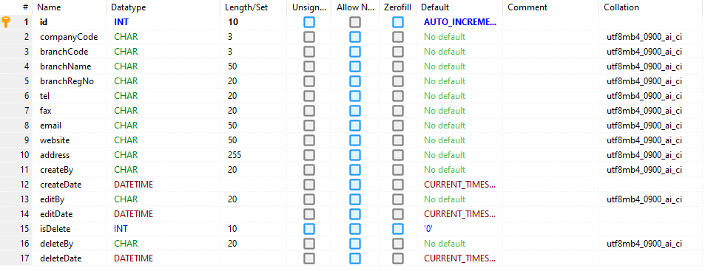
Figure 5.2.16. AdmBranch table
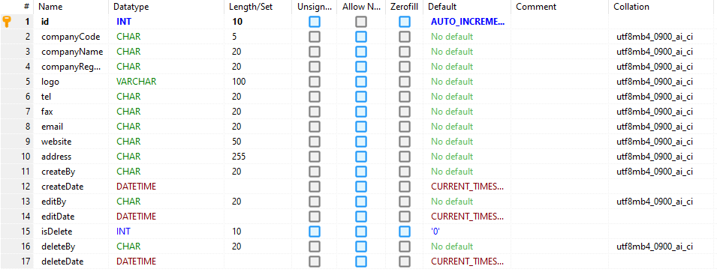
Figure 5.2.17. AdmCompany table
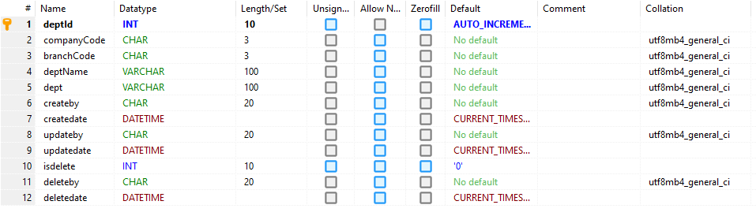
Figure 5.2.18. Department table
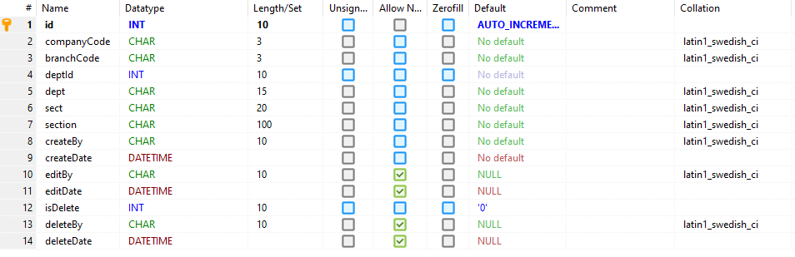
Figure 5.2.19. Section table
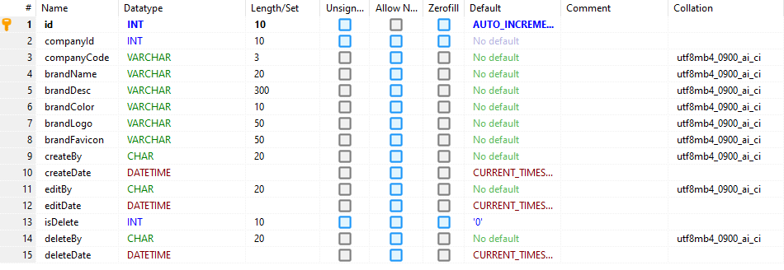
Figure 5.2.20. Branding table
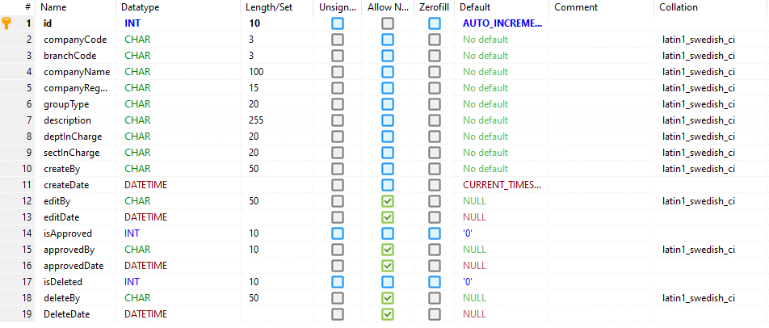
Figure 5.2.21. Companies table
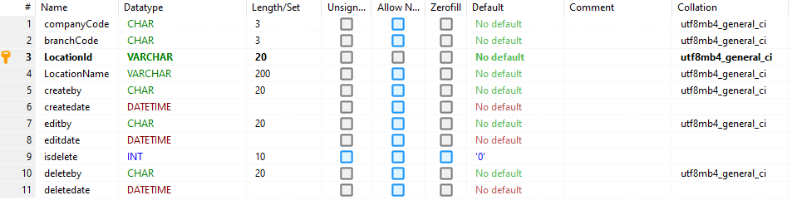
Figure 5.2.22. Location table
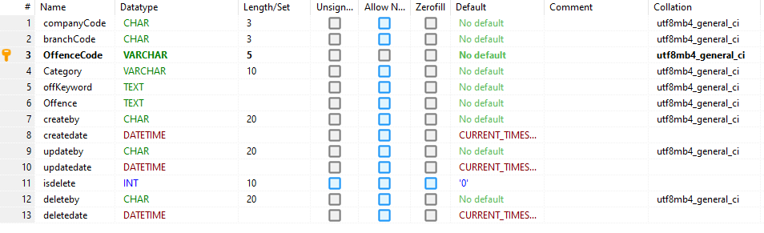
Figure 5.2.23. Offence table
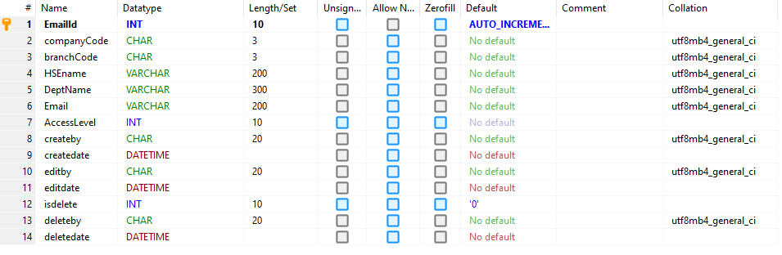
Figure 5.2.24. Email table
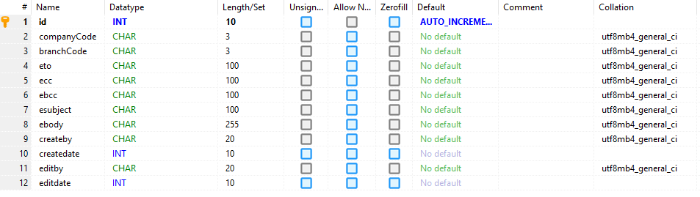
Figure 5.2.25. Email Template table
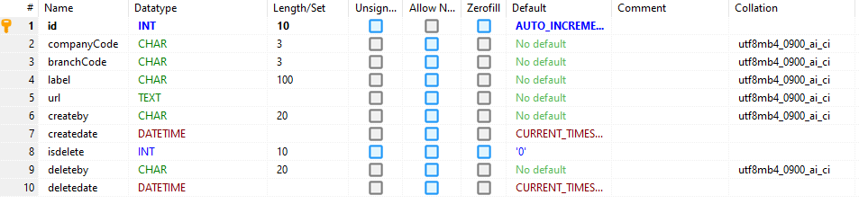
Figure 5.2.26. Favourites table
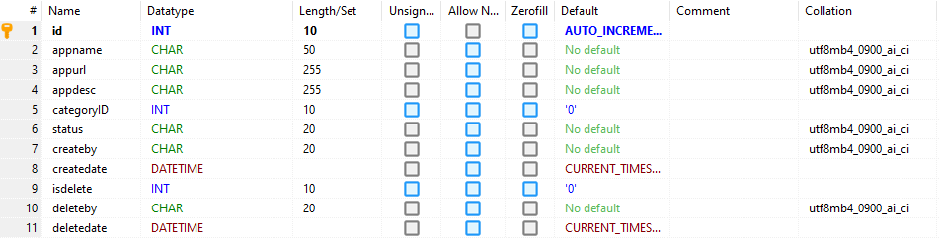
Figure 5.2.27. Apps table
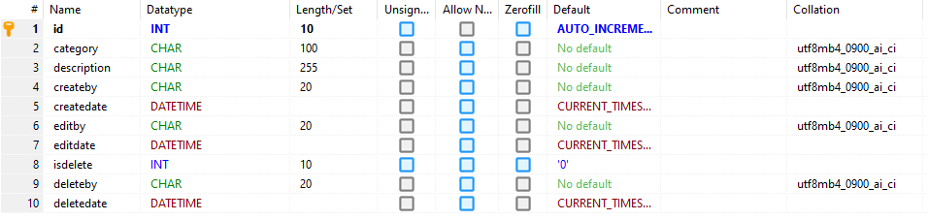
Figure 5.2.28. Apps Category table
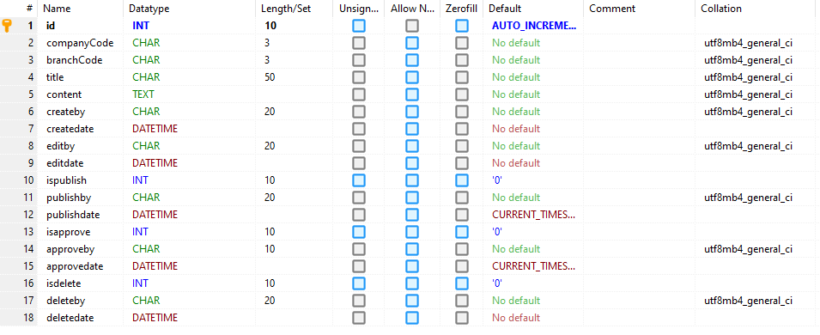
Figure 5.2.29. Pages table
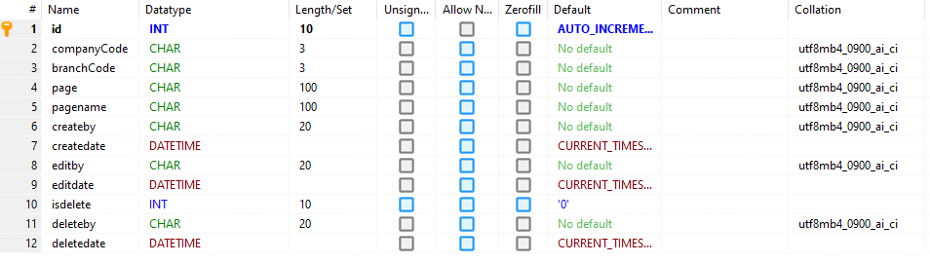
Figure 5.2.30. Page table
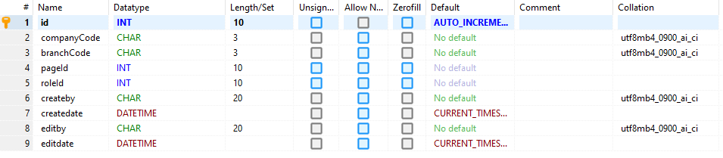
Figure 5.2.31. Page Permissions table
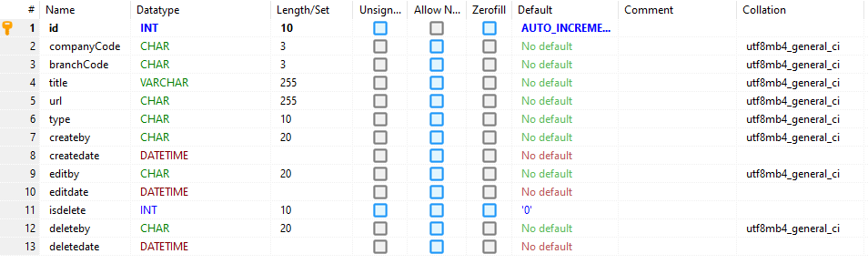
Figure 5.2.32. Tutorial table

6. Interface Design
The User Interface (UI) is web-based and built using the Bootstrap framework to ensure adaptability across modern devices like laptops, smartphones, and tablets.
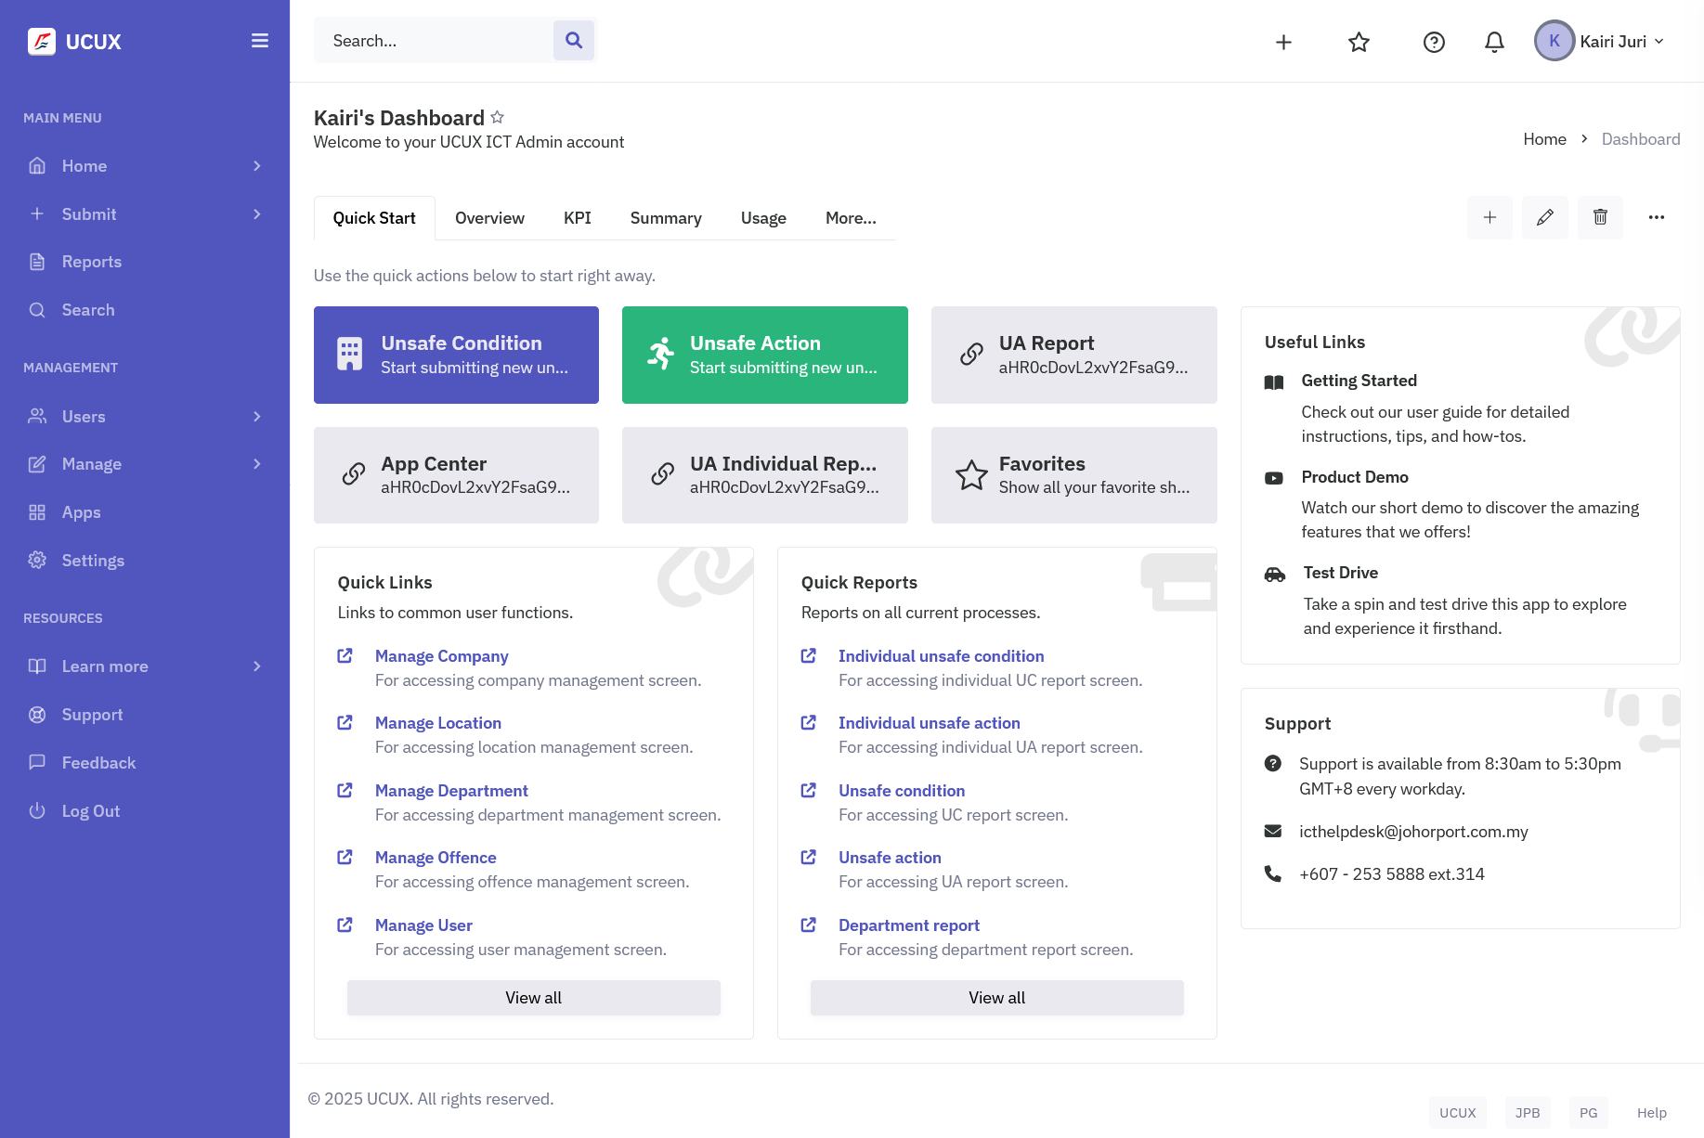
Figure 6.1. Home screen
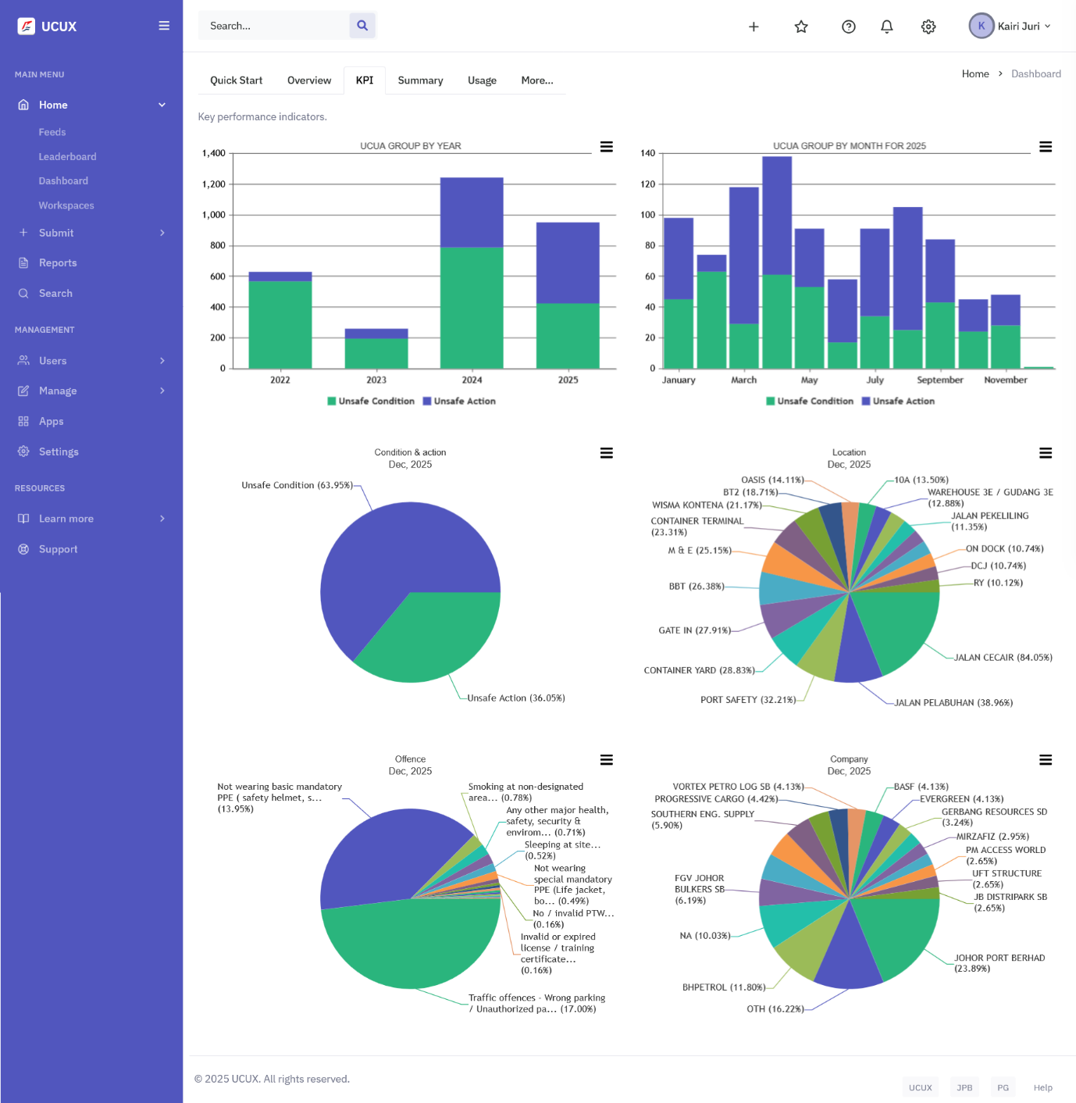
Figure 6.2. KPI Dashboard screen
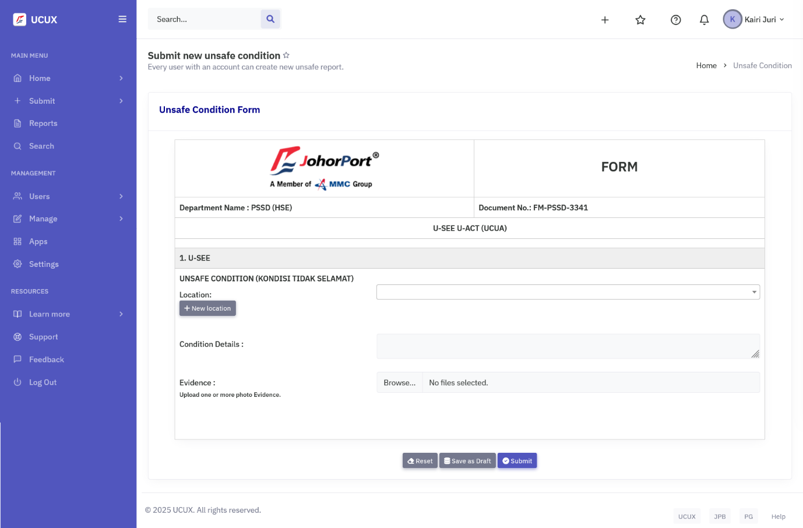
Figure 6.3. Unsafe Condition Form screen
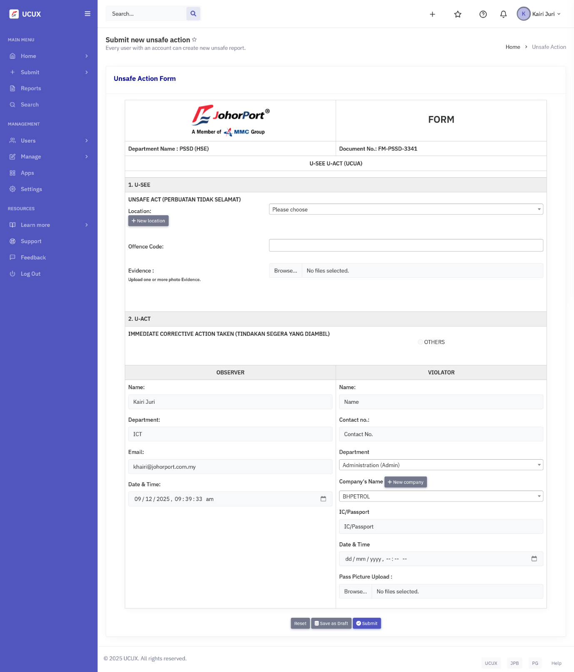
Figure 6.4. Unsafe Action Form screen
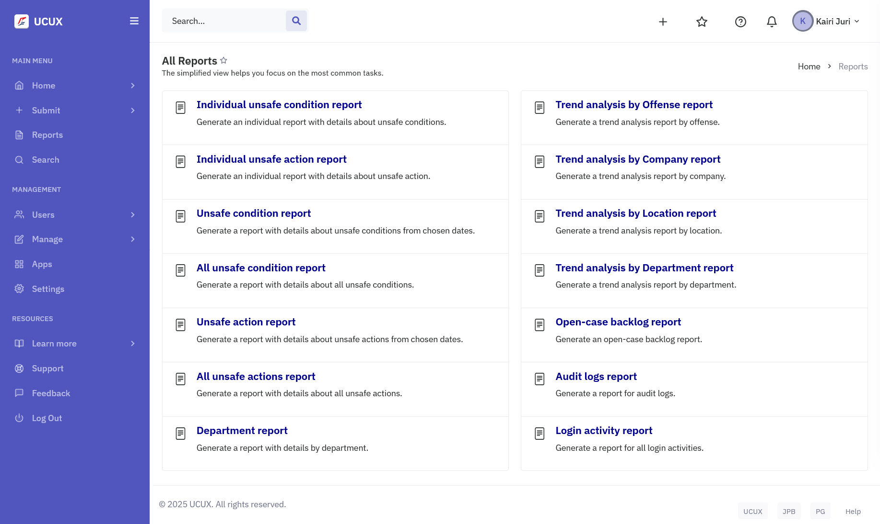
Figure 6.5. All Reports screen
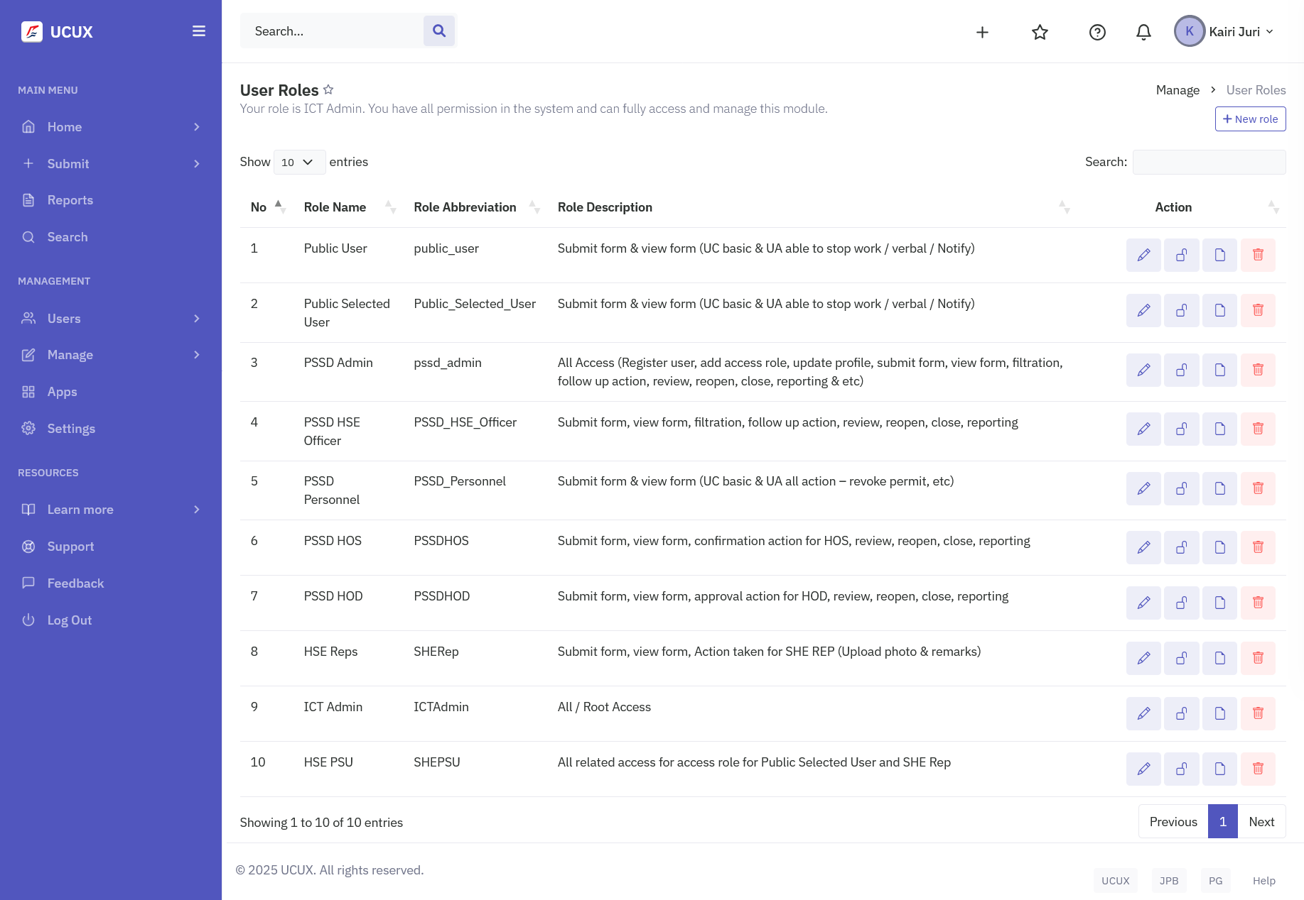
Figure 6.6. User Roles screen

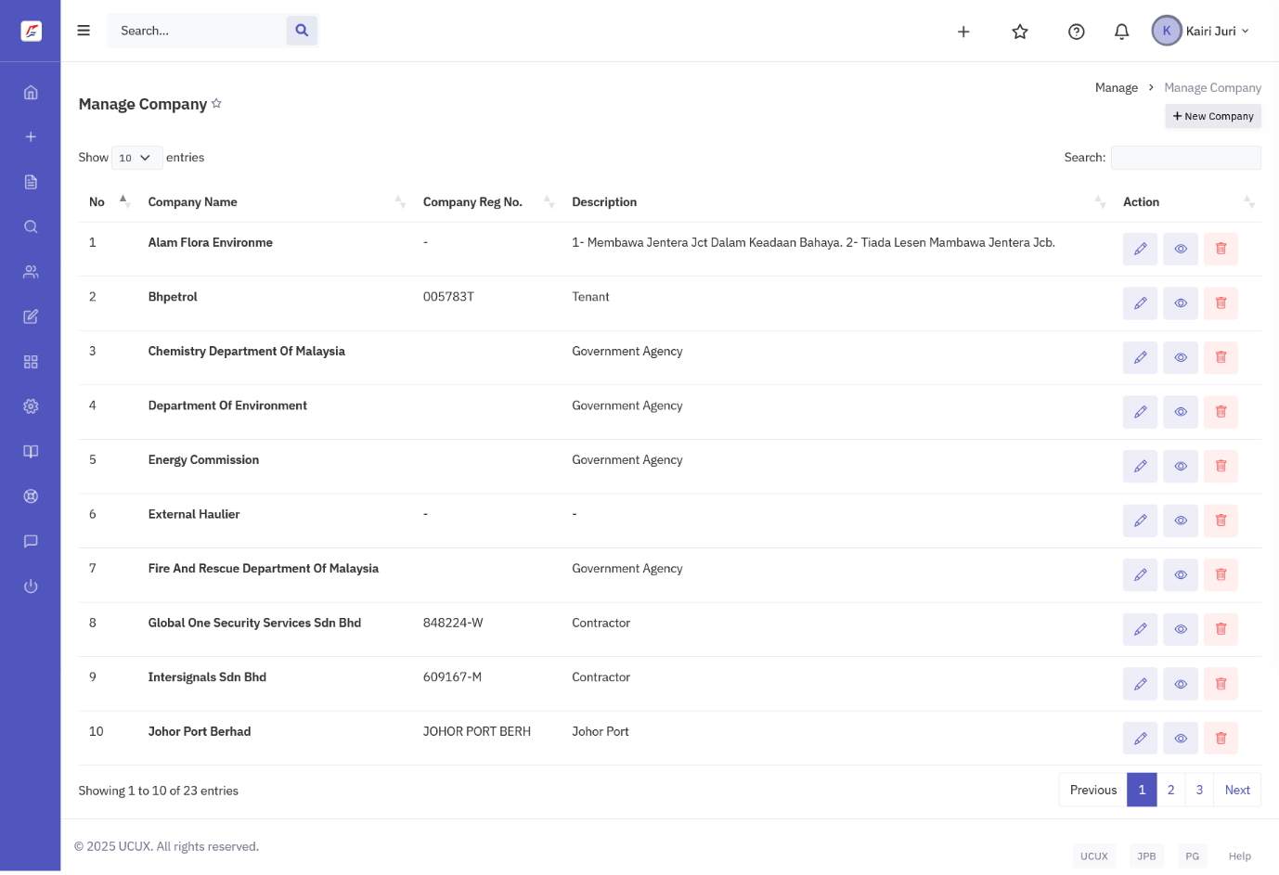
Figure 6.7. Manage Company screen
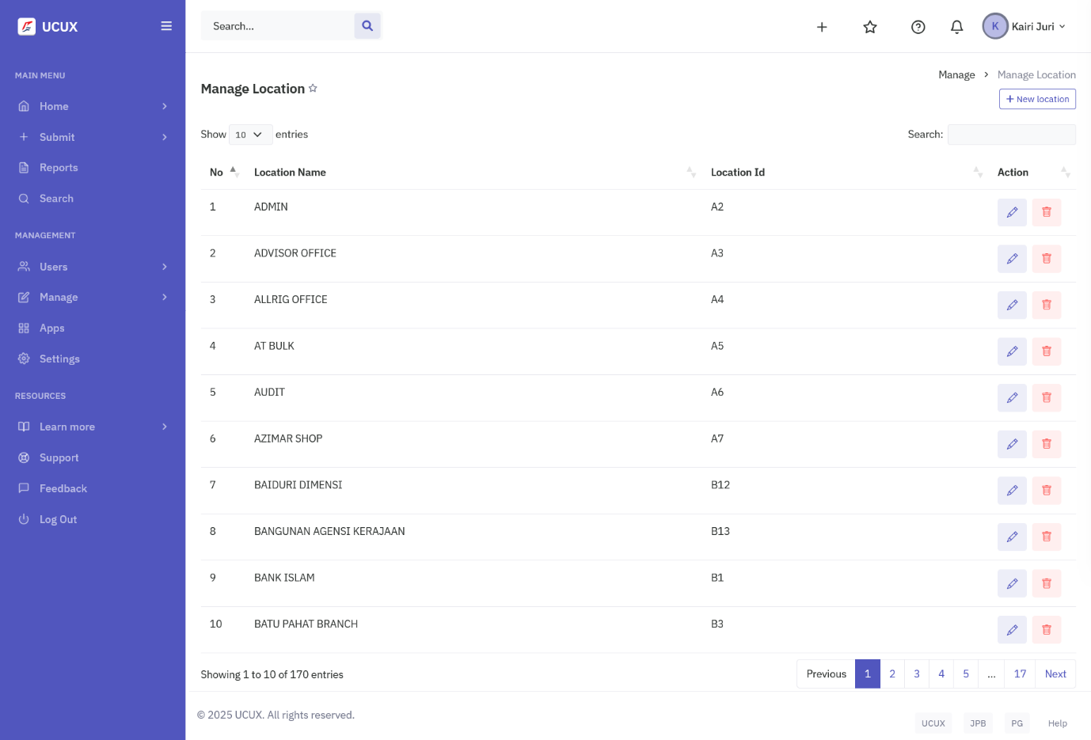
Figure 6.8. Manage Location screen
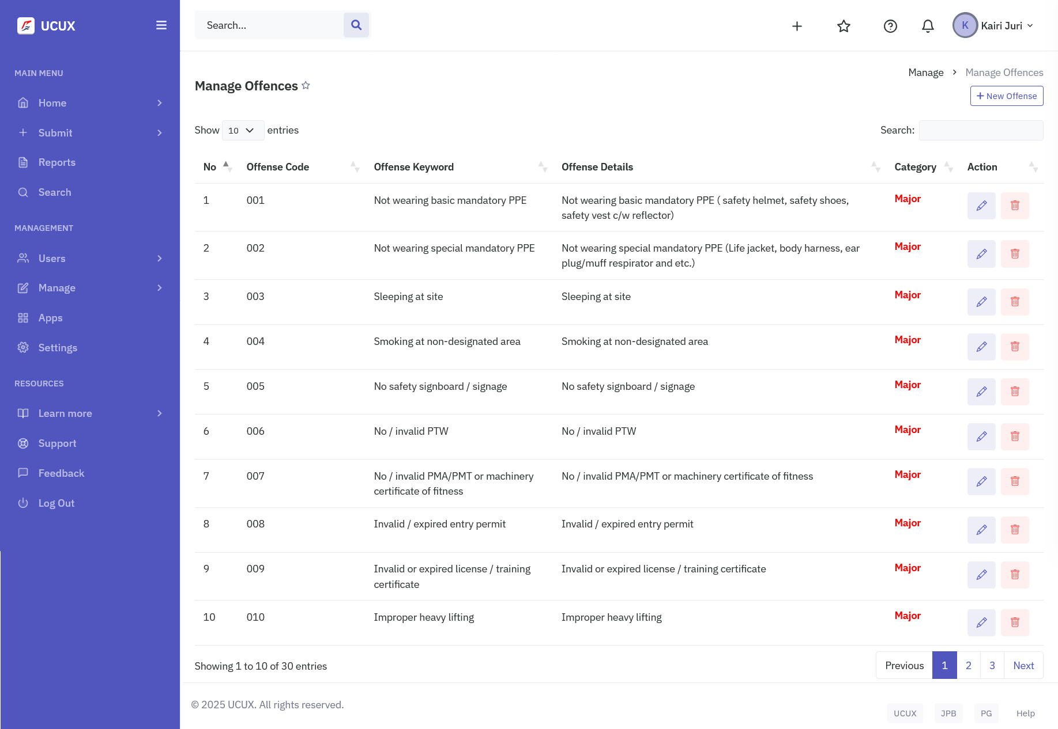
Figure 6.9. Manage Offences screen
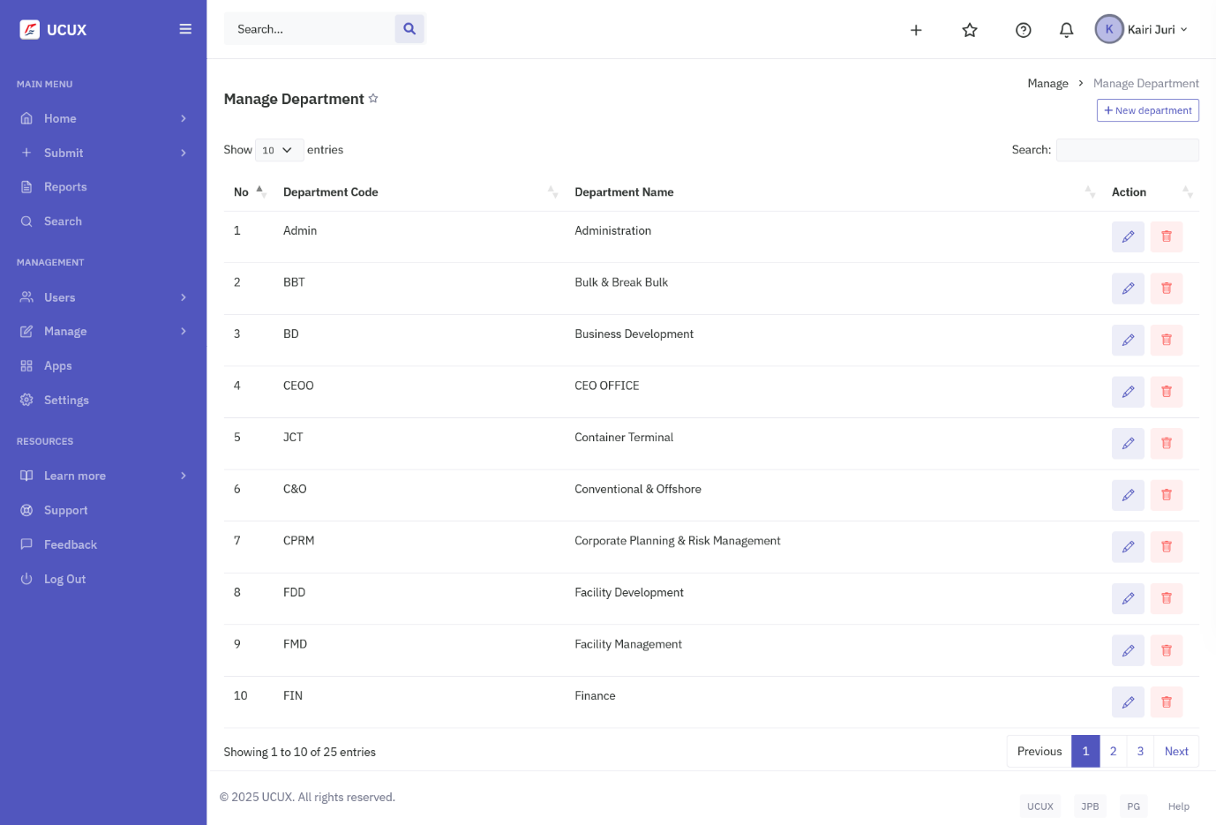
Figure 6.10. Manage Department screen
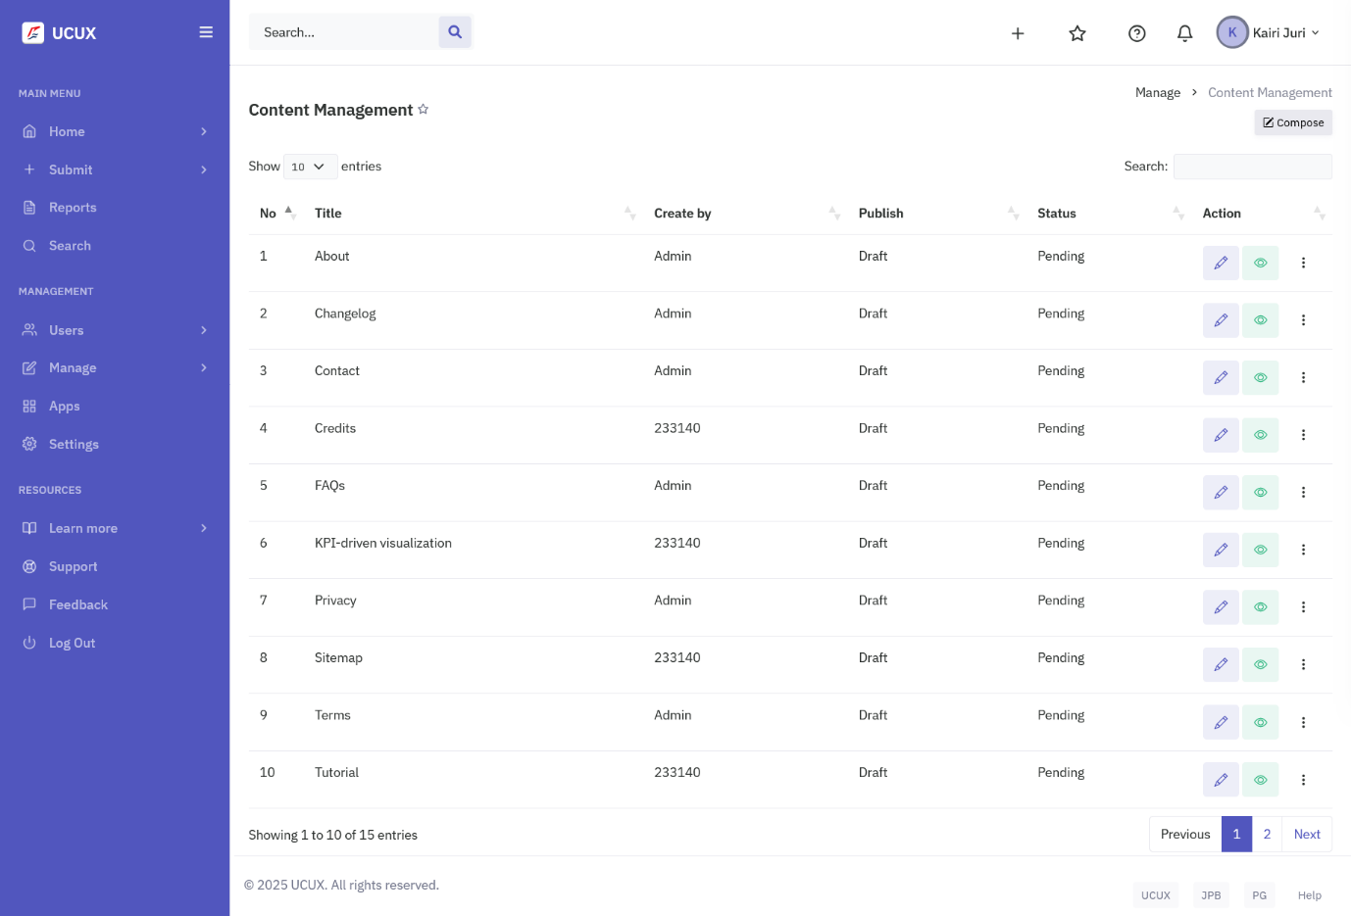
Figure 6.11. CMS screen
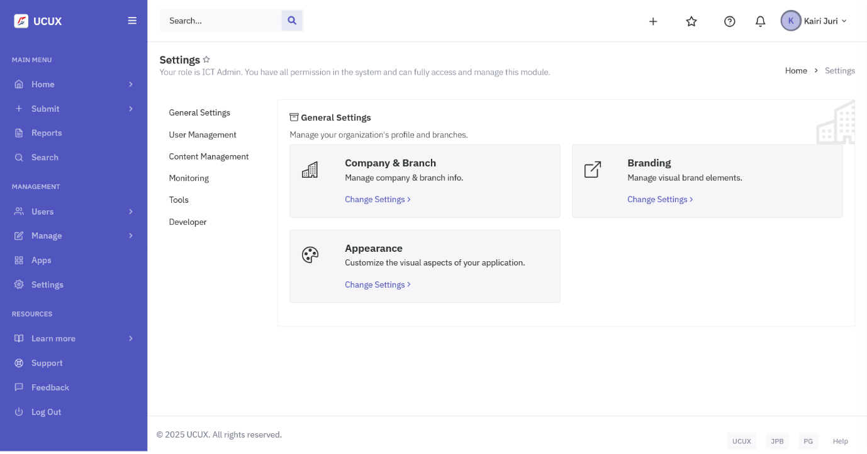
Figure 6.12. Settings screen
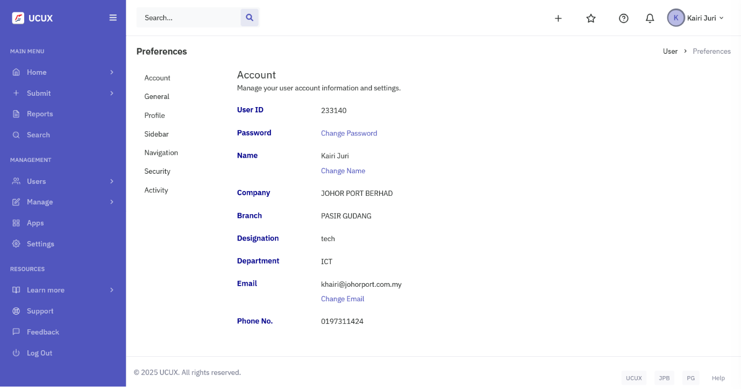
Figure 6.13. Account Settings screen

